A. Installation for Windows computer and Android phone (Part 1 of 2)

1. Download Visual Studio Community by entering this URL <https://visualstudio.microsoft.com/vs/> in your browser, hovering over “Download Visual Studio”, then clicking “Community” 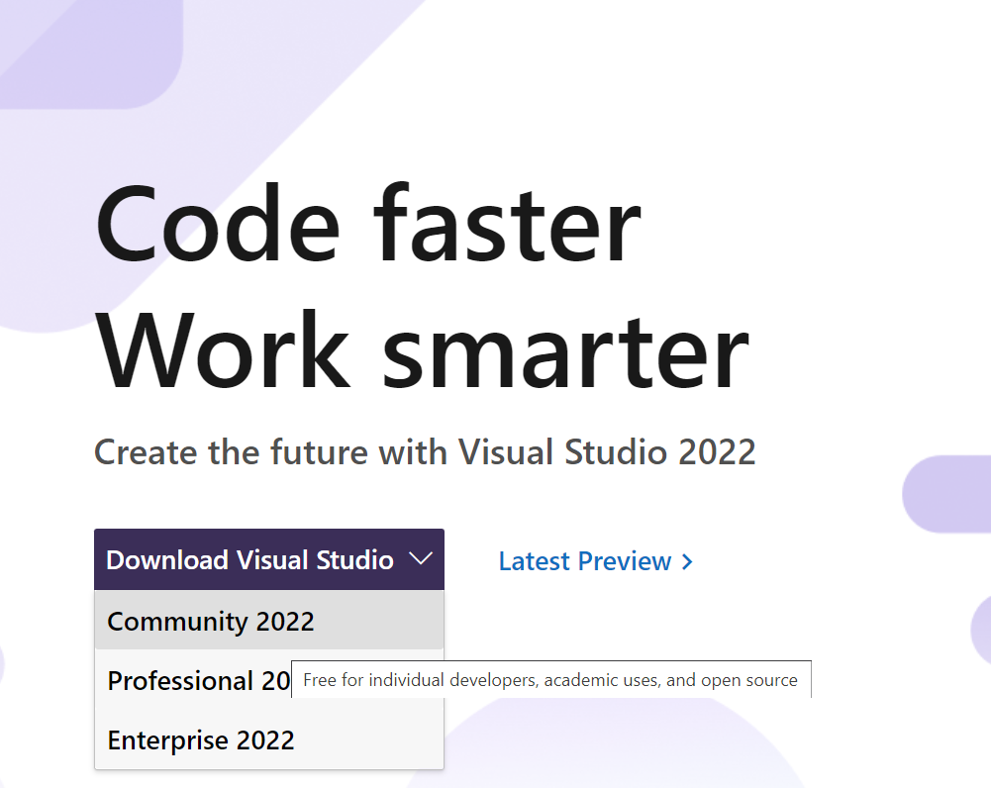
2. Click the downloaded installer

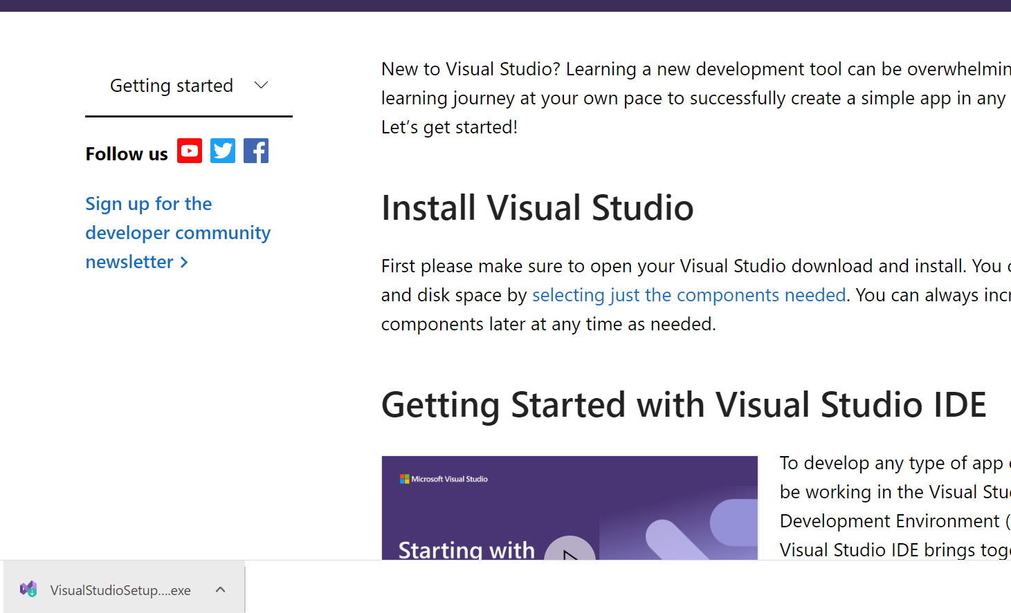

1. Allow administrator rights by clicking “Yes” or entering administrator username and password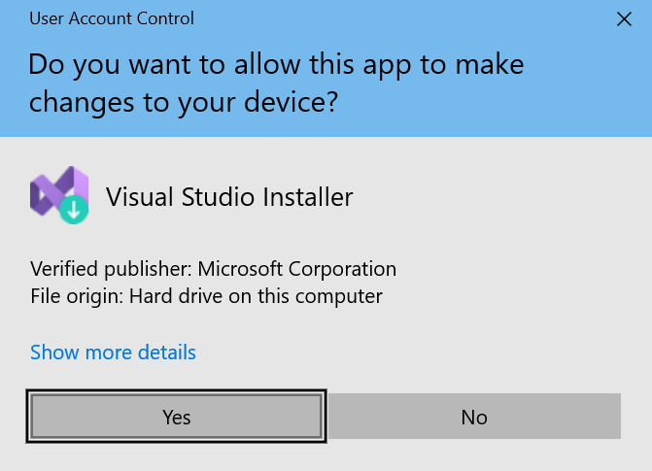
2. Click “Continue” 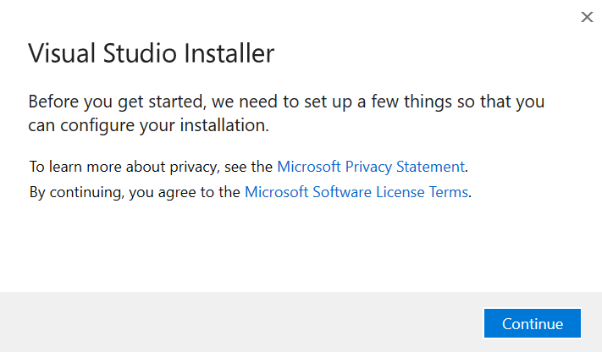
3. Click “Mobile development with .NET” then “Install” 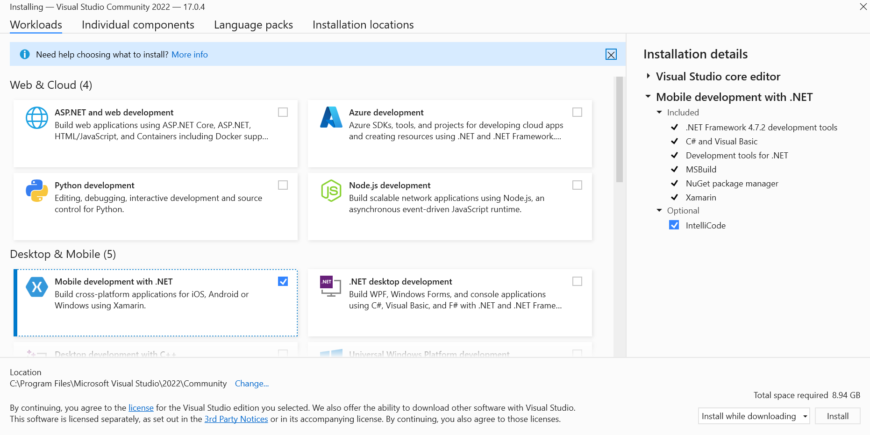
4. While waiting for installation, continue onto step 7 at the same time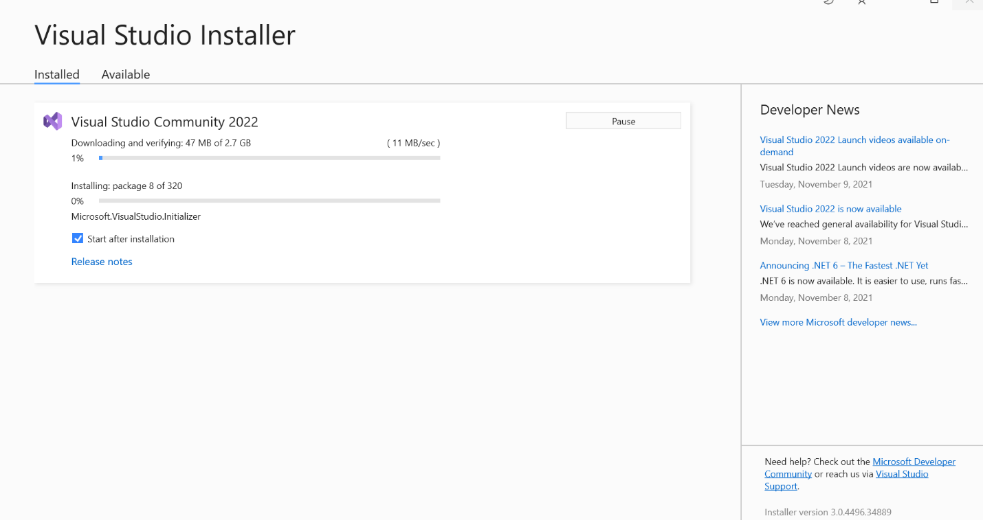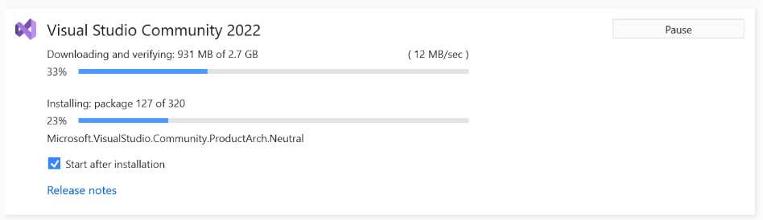
5. Enable USB Debugging in your Android phone   
   (NOTE: the Settings UI is different for each brand, below UI is for stock Android)
   1. Go to “Settings” > (if Android 8.0 or 8.1: “System” > ) “About phone” > Hit “Build number” for 7 times until get a message “You are now a developer!”
   2. Back to “Settings”, open “Developer options” and enable “USB debugging” switch > Tap OK.  
      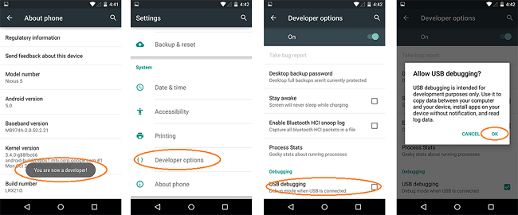
   3. Plug your phone into the computer via a USB cable 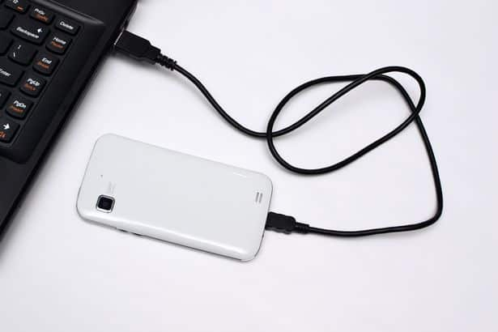
   4. Verify that the “Use USB for” selection appears or use another USB cable capable of data transfer instead of just charging the phone. Press “File transfer/Android Auto”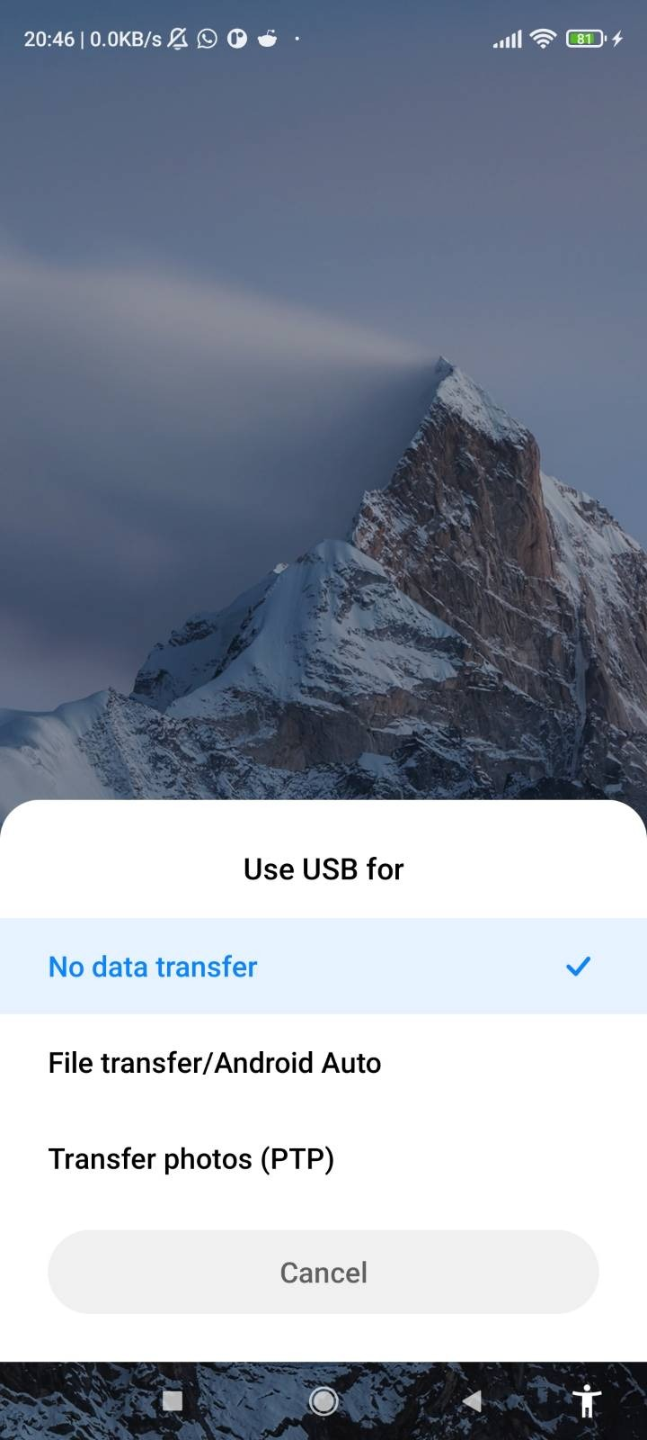
6. After Visual Studio installation completes, click “Not now, maybe later” 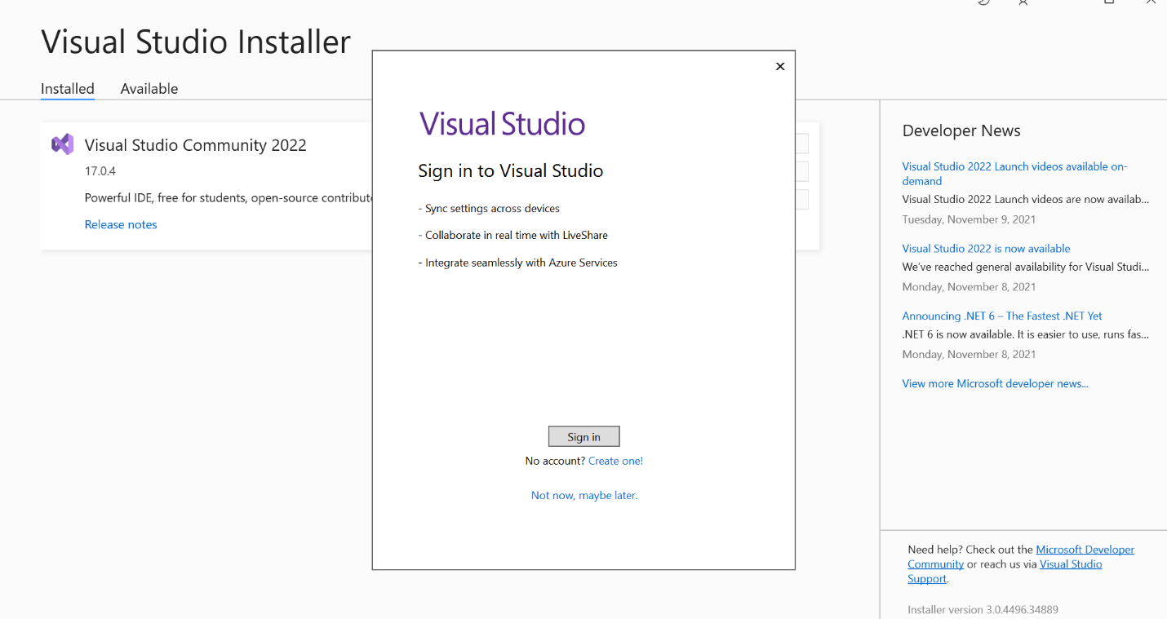
7. Click “Start Visual Studio” 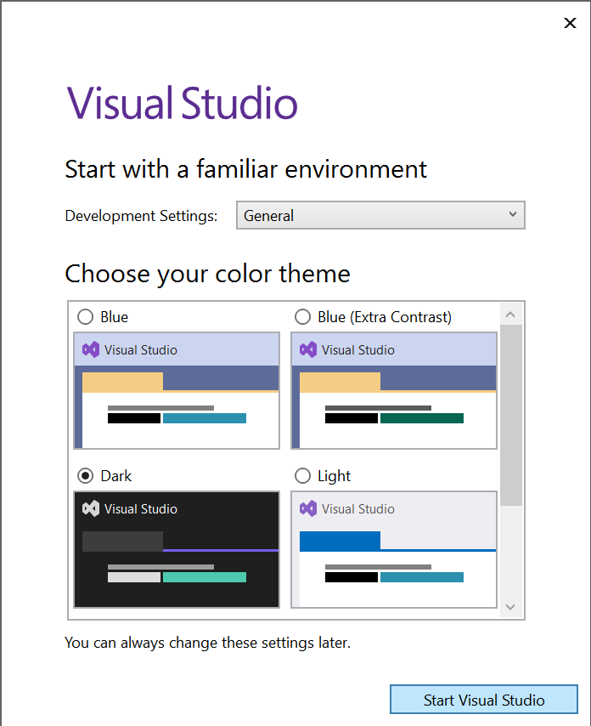
8. Wait a bit more 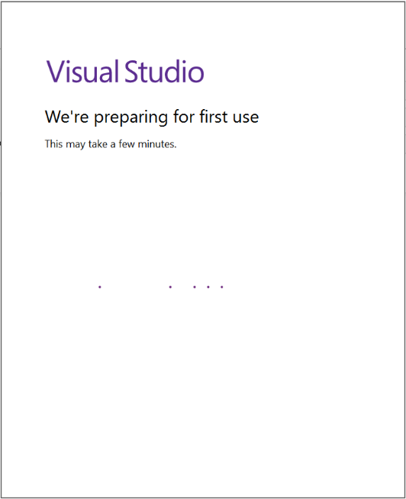

B. Getting the template

1. Click “Clone a repository” 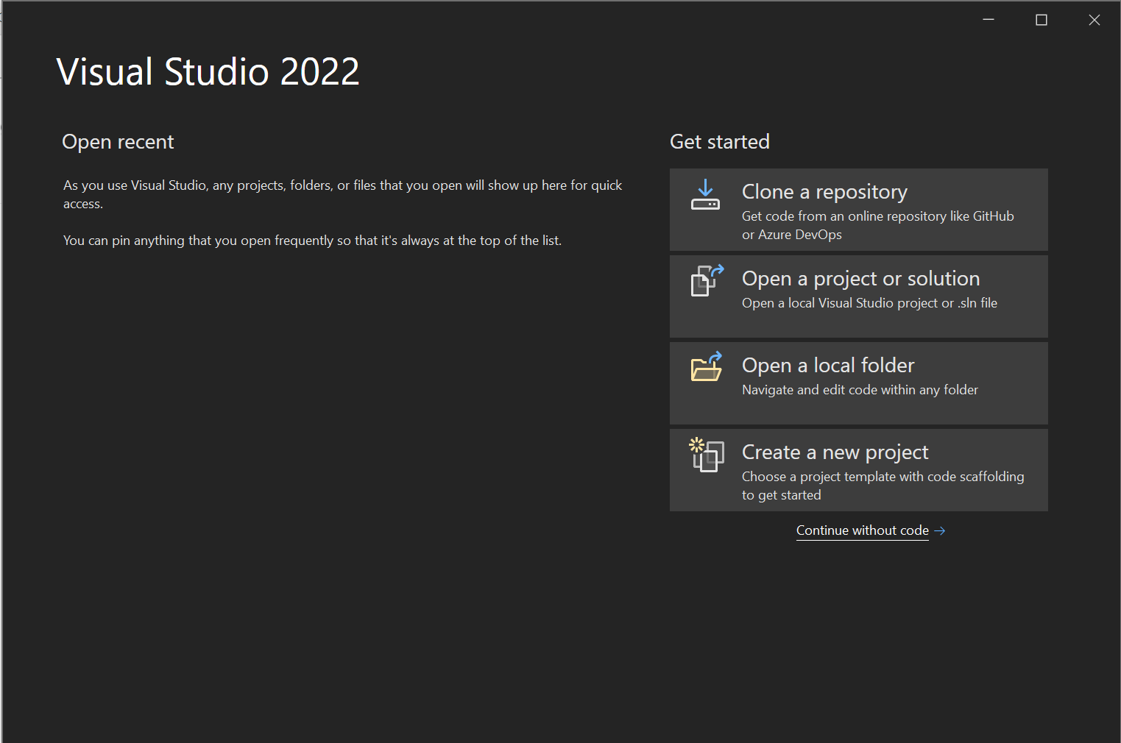
2. Paste https://github.com/Happypig375/PedoApp2 into Repository location, then click Clone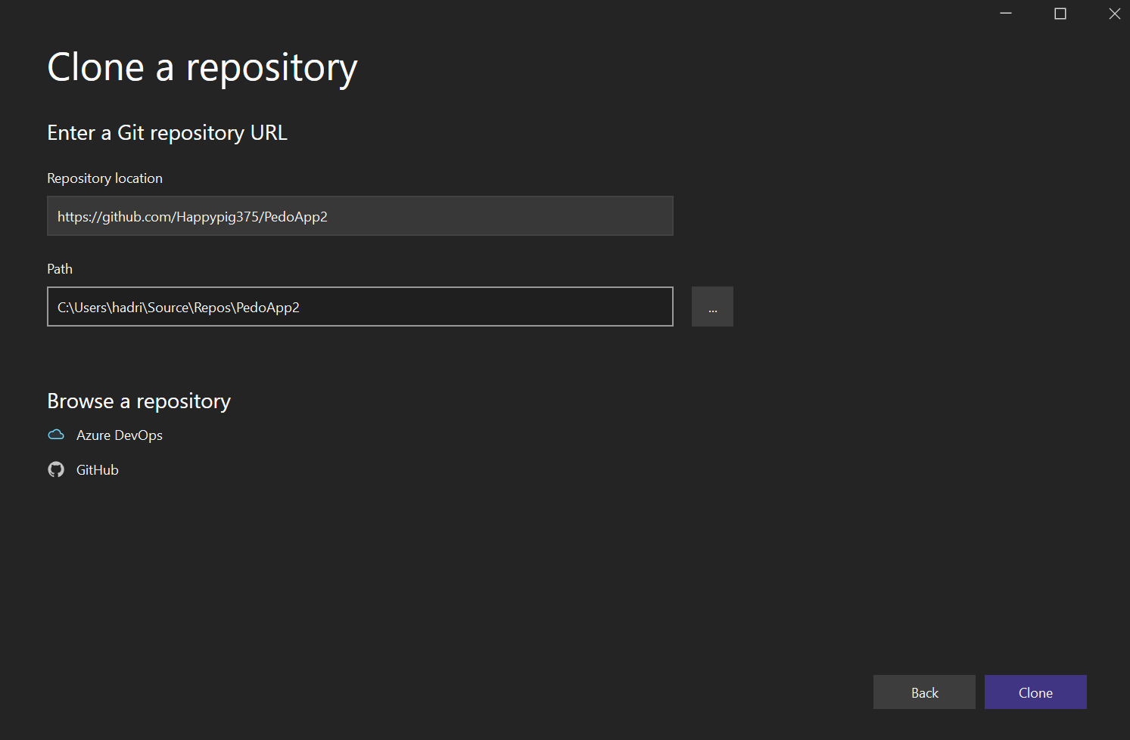
3. Wait for download 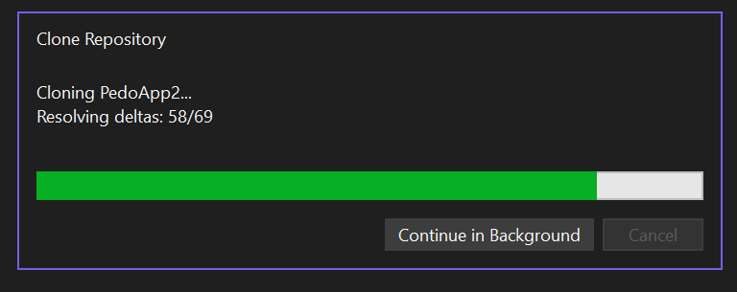

C. Installation for Windows computer and Android phone (Part 2 of 2)

1. Click “Accept” for “Android Sdk License” 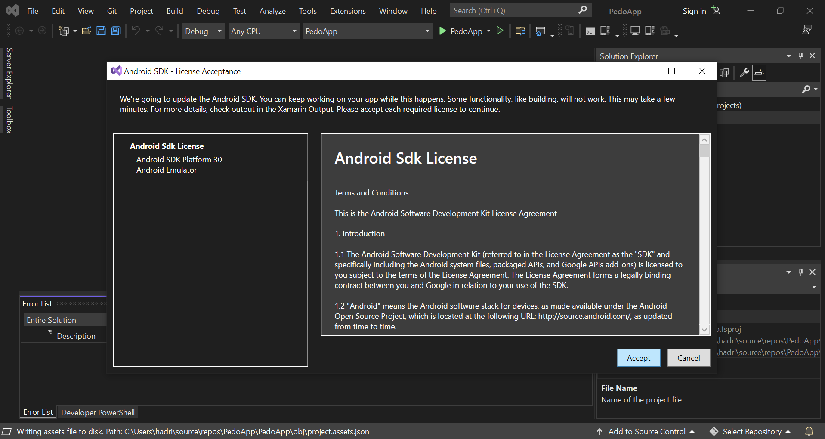
2. Allow administrator rights by clicking “Yes” or entering administrator username and password 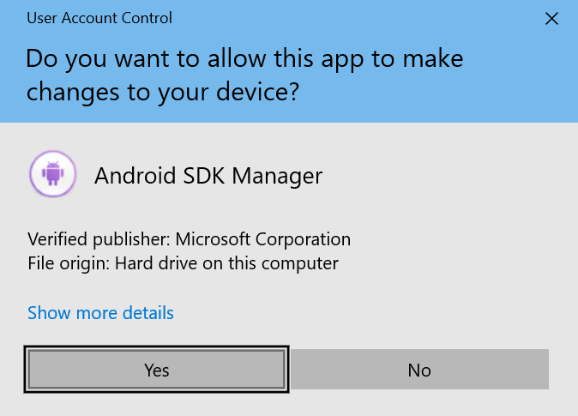

D. App overview

1. Click the dropdown arrow next to “App” and click “App.Android”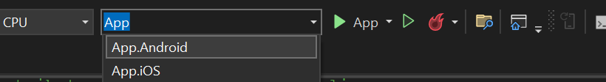
2. Click the dropdown arrow to the right of the green right-pointing triangle and click the option with your phone model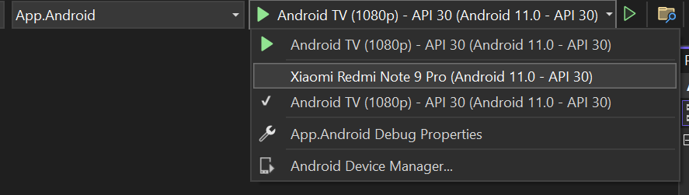
3. Press the green right-pointing triangle and wait for the app to build. Meanwhile, look at your phone for the next step  
   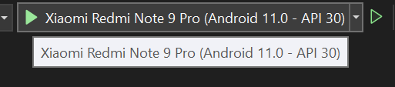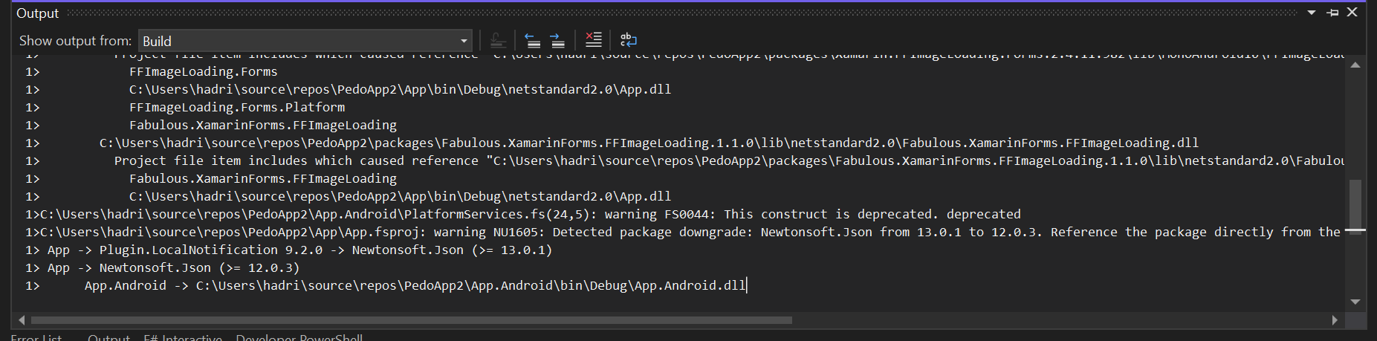
4. Press “Install” once the installation prompt comes up. You only have 10 seconds to accept, or accept the computer screen error prompt and repeat from the previous step  
   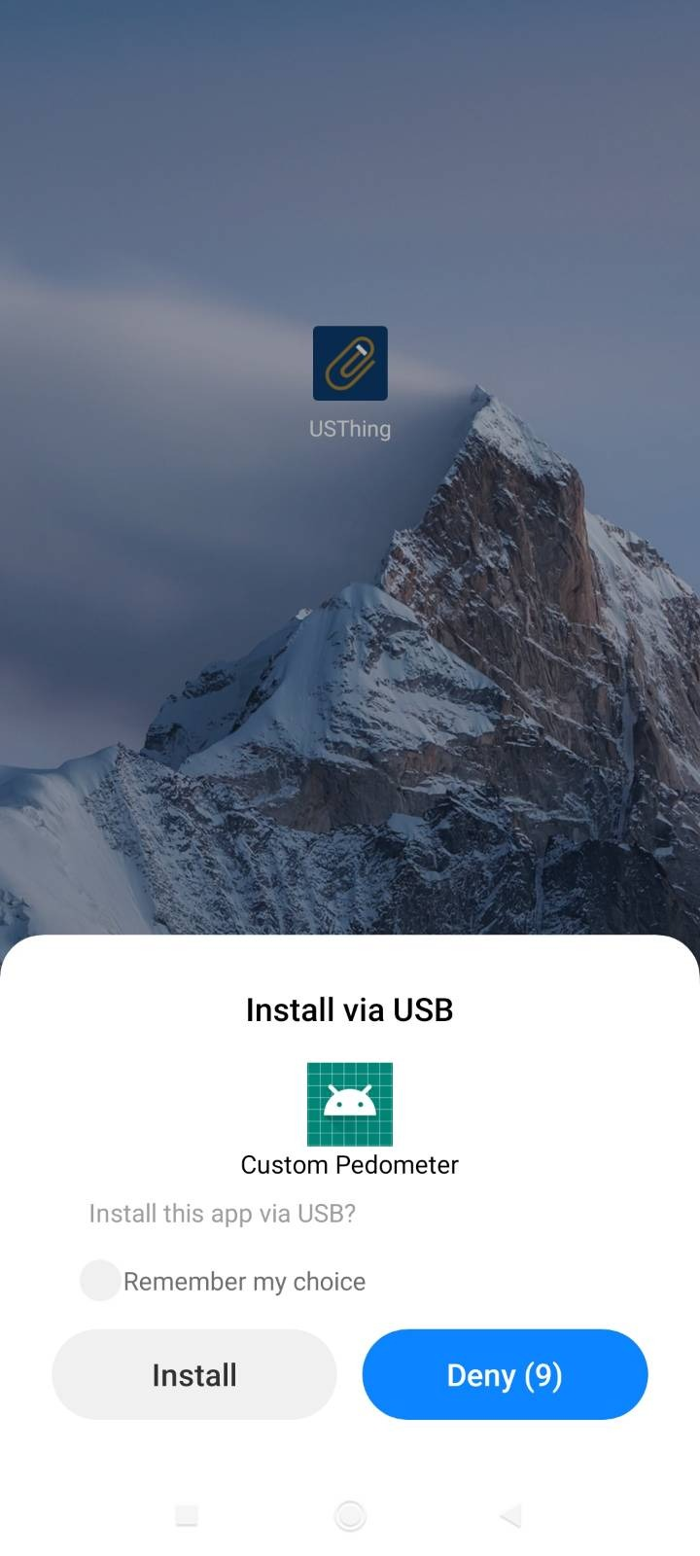
5. Press “Allow” 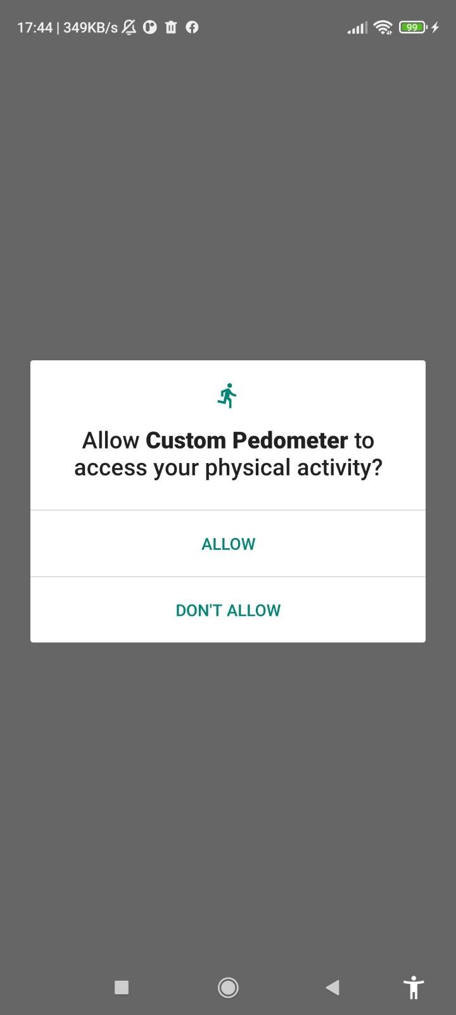
6. Test the pedometer by walking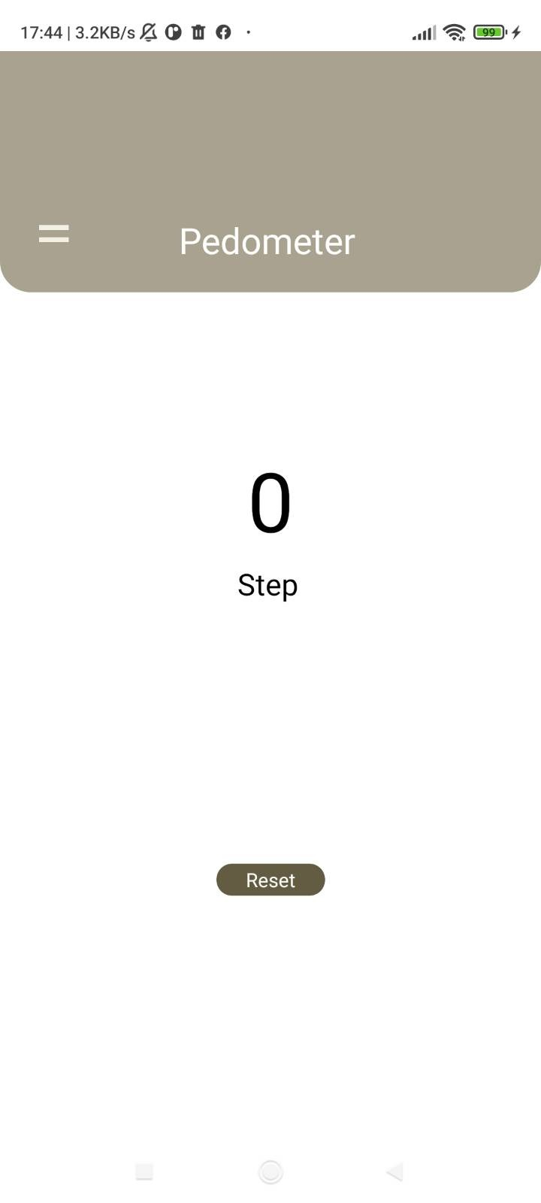
7. Press the menu button
8. Press “Alarm” 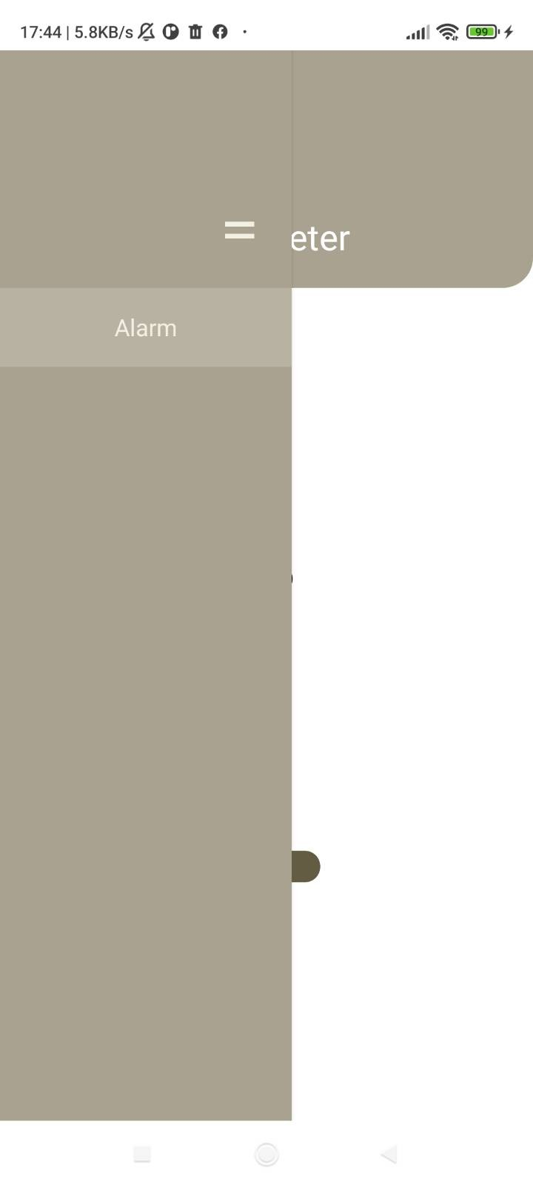
9. We have some bugs here! 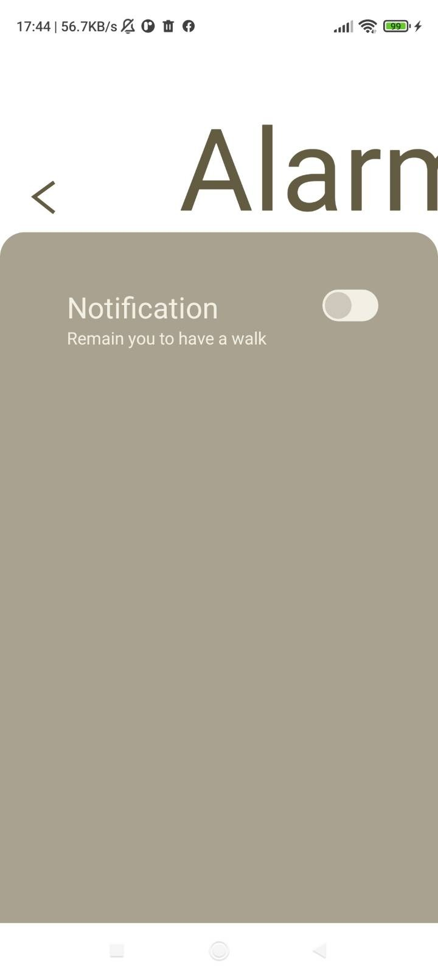

E. Bugfixing

1. Click to open Solution Explorer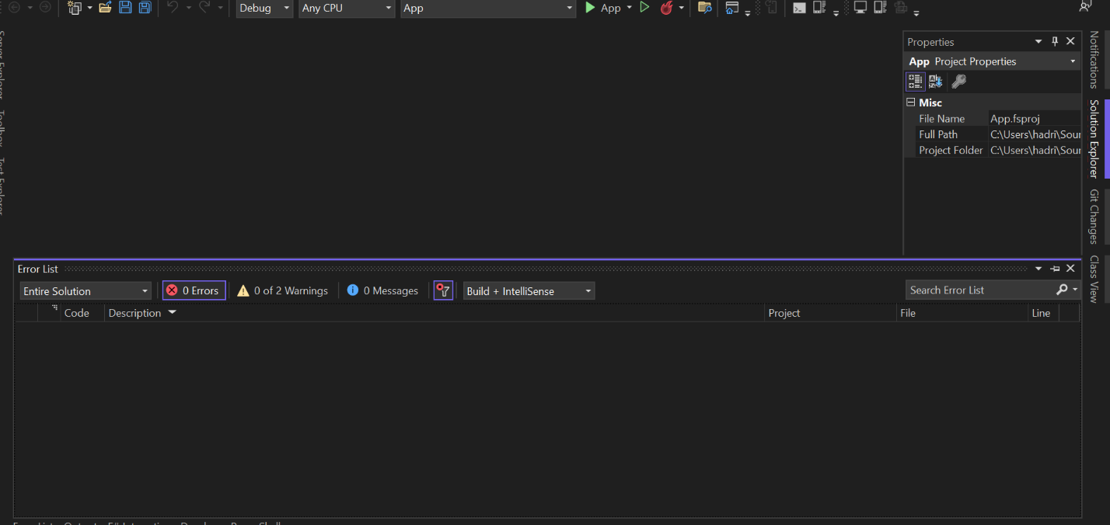
2. Click to open “App” dropdown 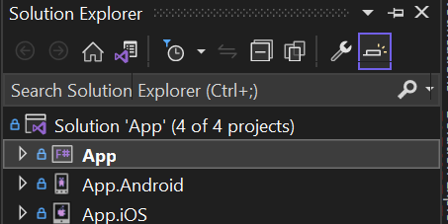
3. Double click to open App.fs 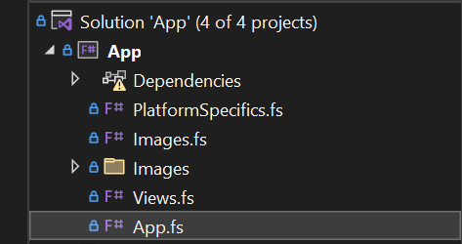
4. Hover over “Edit” at the top, then hover over “Find and Replace”, then click “Quick Find” 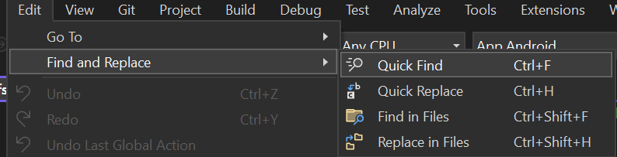
5. Type “todo” in the find prompt at the top right corner 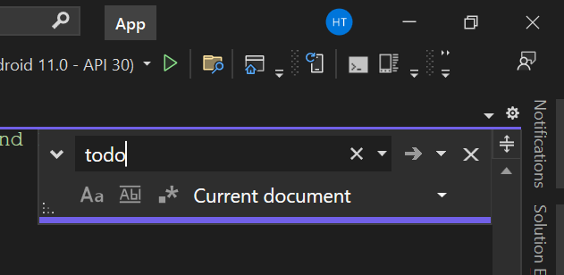
6. See the “TODO”s highlighted. The vertical scroll bar also highlights for lines containing these TODOs.

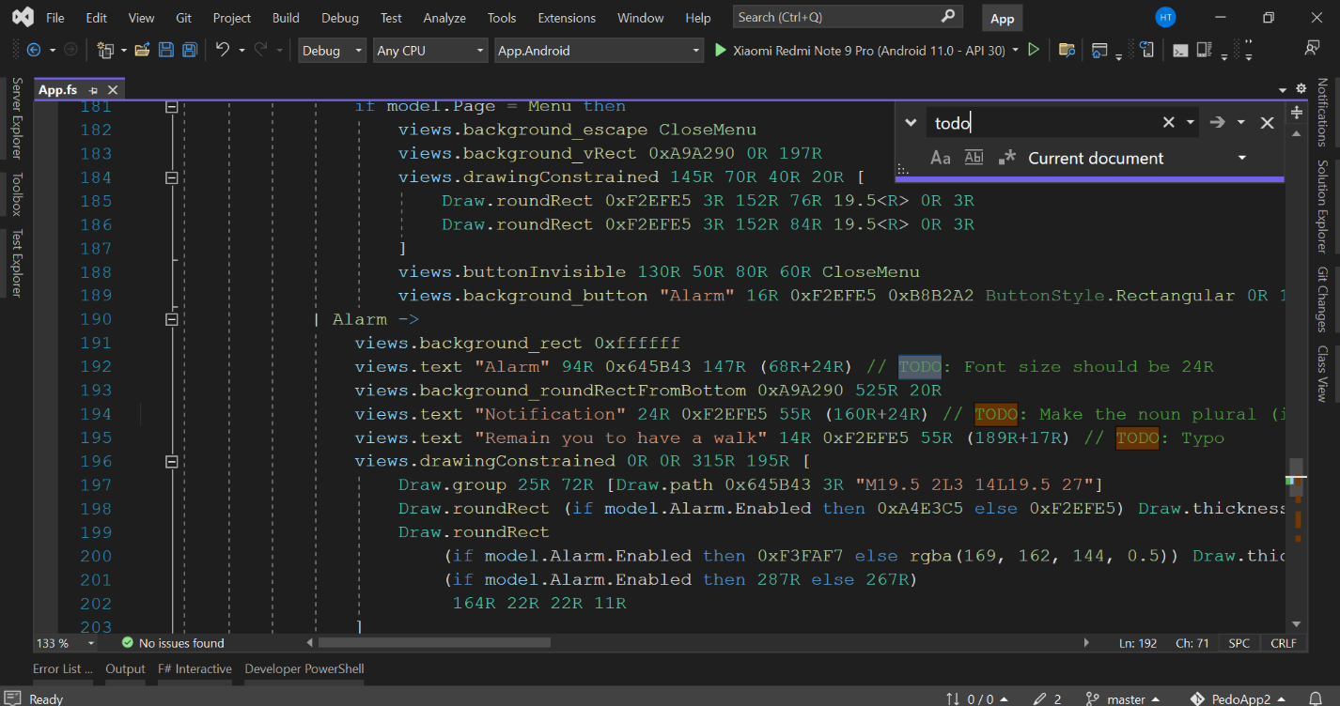

1. For example, on line 205, we have a TODO: Set the height to 50R.  
   First try to understand what that line is doing by hovering over the yellow part buttonInvisible  
   
2. Explanation: this is an invisible button, with its left edge at 250 (“R”atio-defined units), top edge at 150 (“R”atio-defined units), width of 75 (“R”atio-defined units), and height of 0 (“R”atio-defined units), and pressing it will cause a SwitchAlarm. It’s obvious that a button of zero height will not be desirable and the TODO tells us to change the height to 50 (“R”atio-defined units) instead, and after changing 0R to 50R, click the green right-pointing triangle again to see the effect of our change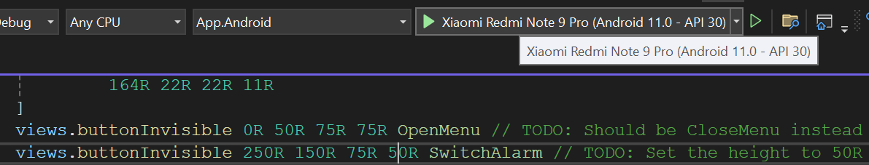

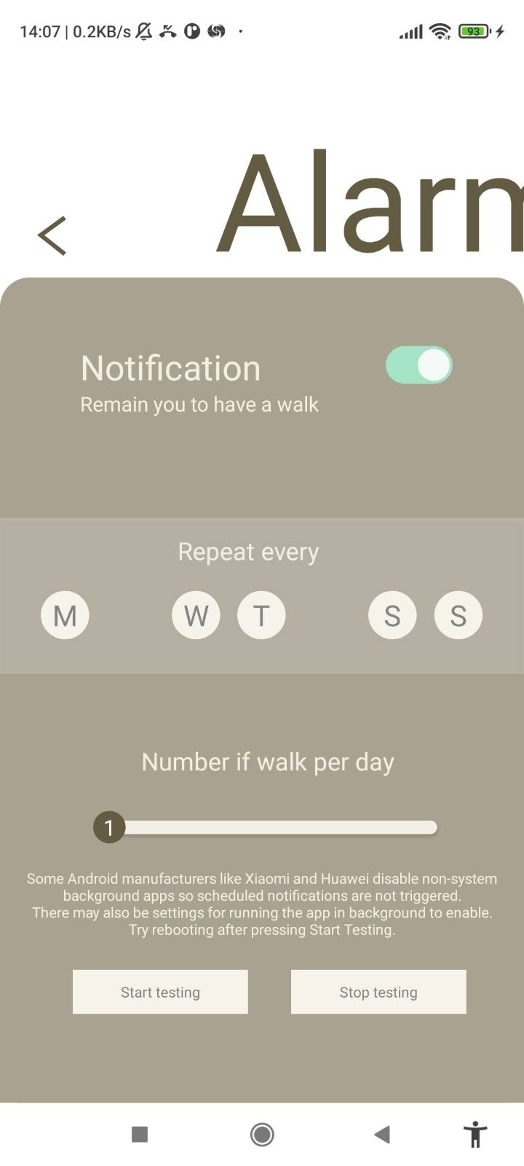

1. There are still more bugs to fix  
   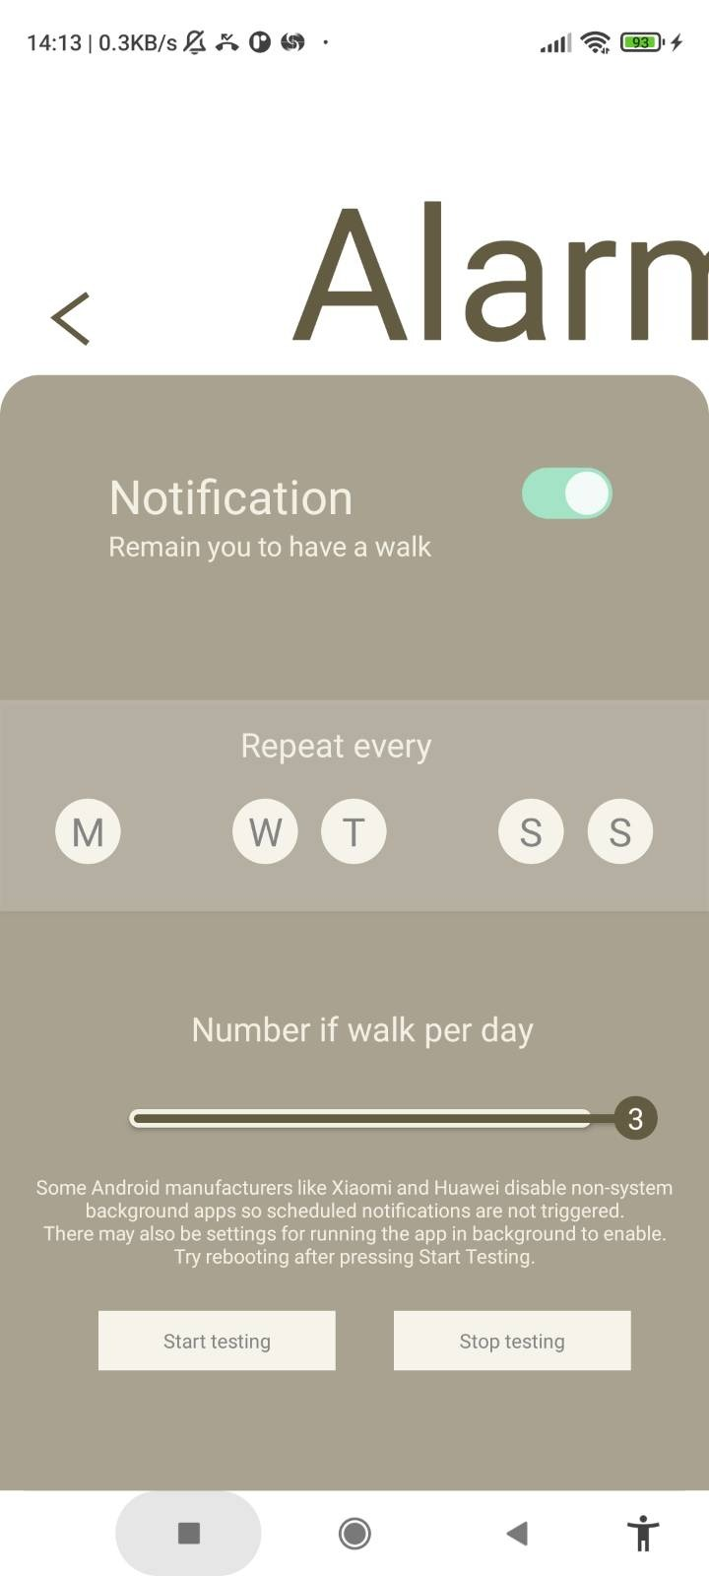
2. Click “Stop debugging” to return to editing code 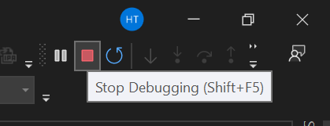
3. We can delete the TODO since we have completed it
4. As another example, let’s fix the slider getting over the right limit by looking at line 227  
   Explanation: We have the x coordinate touched, subtract it by 22R/2 (which is half of the knob  width so that we get where the left edge of the knob  should be), take the minimum between 384R and it, take the maximum between 64R and it, then raise the MoveKnob message (move the left edge of the knob  to that coordinate). It can be inferred that the coordinate of the left edge of the knob  is limited to a range between 64R and 384R. Meanwhile, the TODO tells us that the right limit should be at 284R instead. Therefore, we should change 384R to 284R
5. Click the green right-pointing triangle again 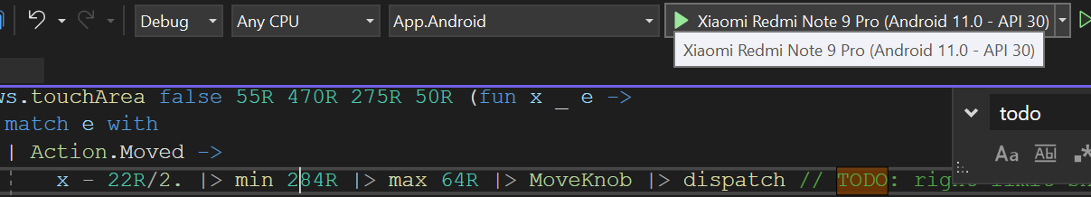
6. Navigate to the Alarm page, now the slider is unable to be moved past the right edge 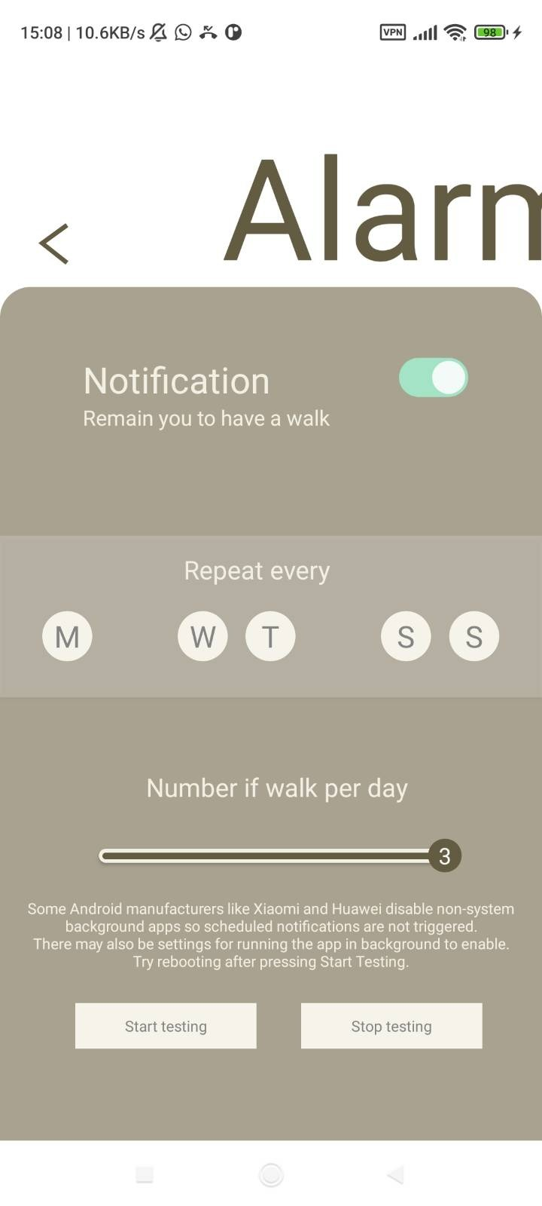
7. Delete the TODO since we have completed it
8. As the last example, we look at line 213 where we need to add another button for Tuesday. We can observe the code surrounding this line, where we can infer a pattern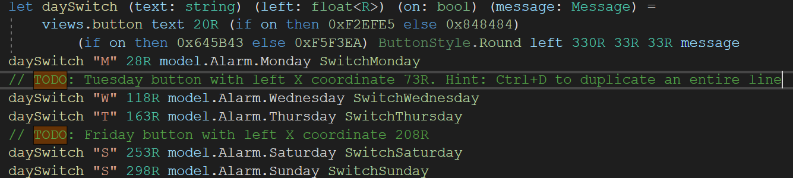
9. As the hint says, we can press Ctrl and D simultaneously to duplicate an entire line. Move the cursor onto line 212 and press Ctrl and D simultaneously
10. From the pattern we observed, we should change "M" to "T", 28R to 73R, Monday to Tuesday, and SwitchMonday to SwitchTuesday
11. Click the green right-pointing triangle again 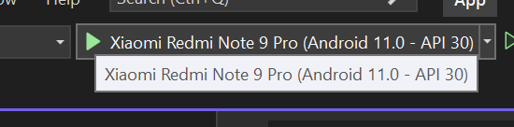
12. Navigate to the Alarm page, now we can see the new Tuesday button  
    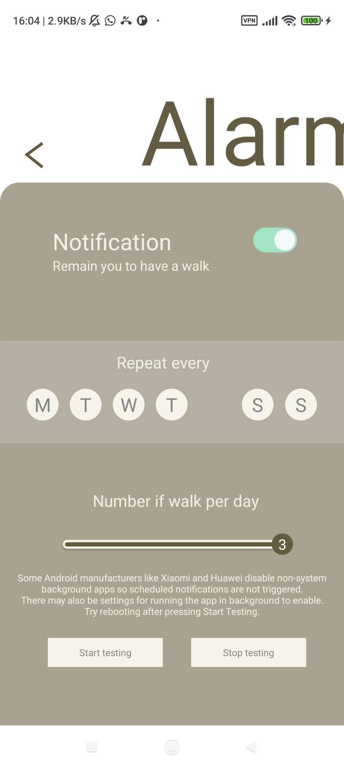
13. Delete the TODO which we just completed

Fix the other bugs as specified in the remaining TODOs so that the Alarm page looks like as below  
Hint: the TODO: Typos have the desired text shown below  
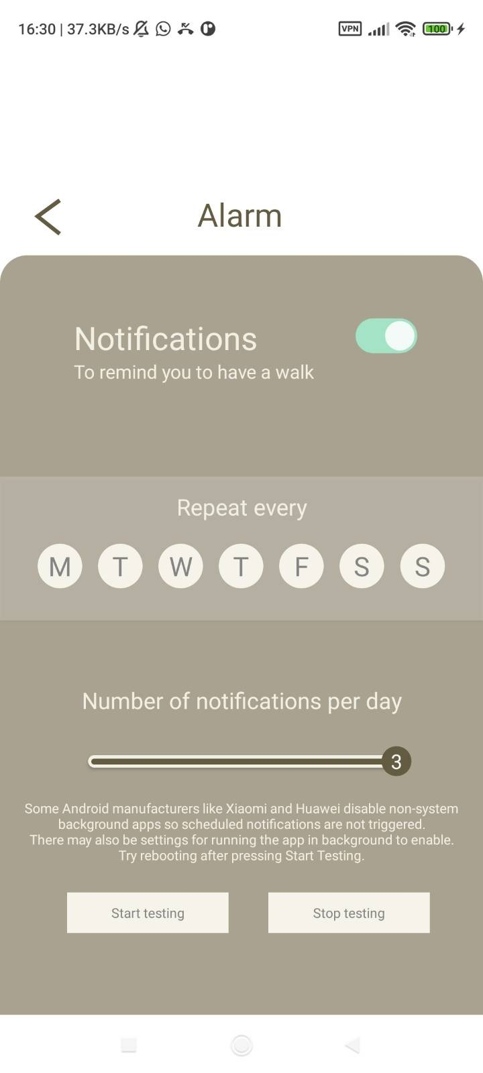

F. Color customization

1. 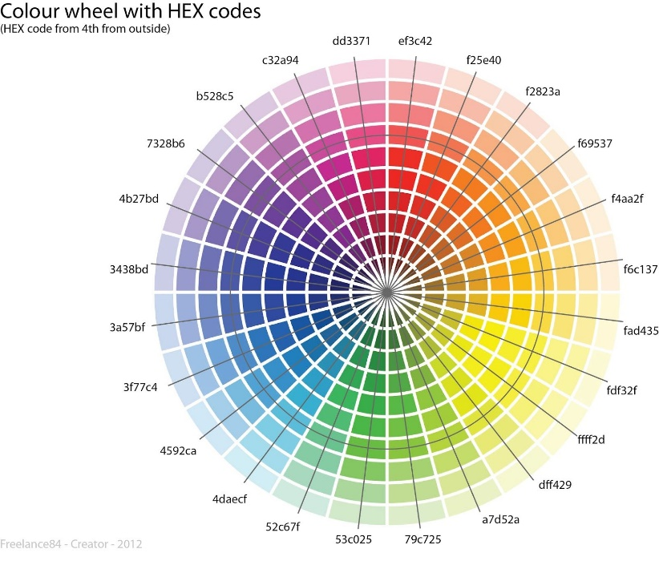There are various places in the code starting with 0x, such as line 178:   
   When hovering over textCenter,  
   we find that 0x000000 corresponds to color. To understand how this can represent a color, we can view 0x000000 as three parts: 0x000000 where the first two characters after 0x designate the amount of redness, then the next two characters designate the amount of greenness, and the final two characters designate the amount of blueness. These characters are hexadecimal digits, so instead of incrementing 09 to 10, 09 is incremented to 0A, then 0B, 0C, 0D, 0E, 0F, 10, …, 19, 1A, …, 1F, 20, …, 9F, A0, …, FE, FF. From 00 to FF, there are 256 possibilities in total. Therefore, from 0x000000 to 0xFFFFFF, there are 2563 = 16777216 possible colors. 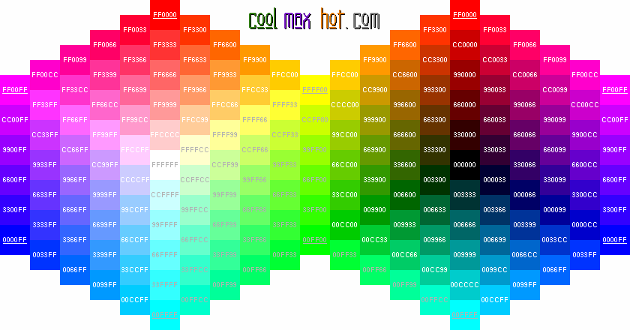  
   From the above chart, we can see how mixing red, green, and blue can produce different colors, using combinations of 00, 33, 66, 99, CC, and FF, as well as seeing how incrementing red, green, or blue affects the color. Together, a color wheel can be formed, as seen in the chart to the right
2. 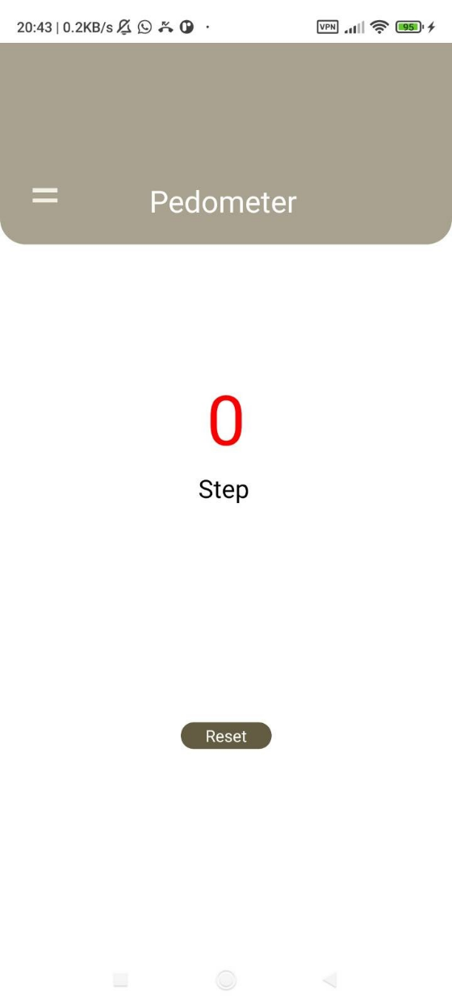Change 0x000000 to 0xFF0000 and click the green right-pointing triangle again. The counter should now have red text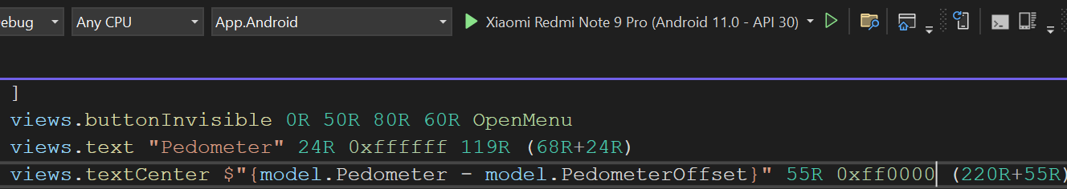
3. Try changing other colors and click the green right-pointing triangle to see the effects

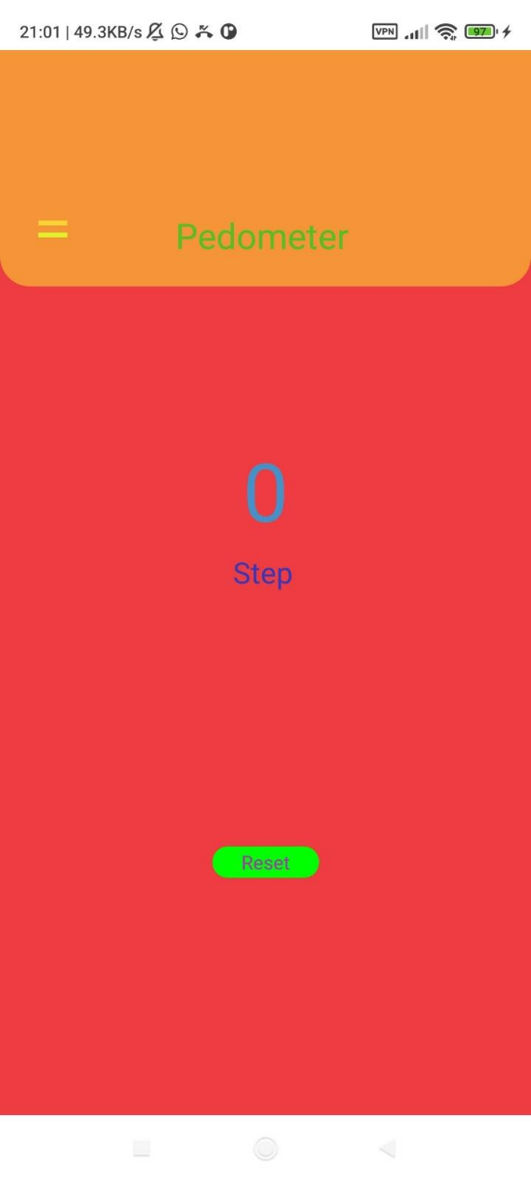

G. Unique app ID

1. To publish the app to the Google Play store, we need to first generate an APK file. However, before doing that, we should ensure a unique app ID so that we won’t be recognized as an existing app. In Solution Explorer, right click App.Android

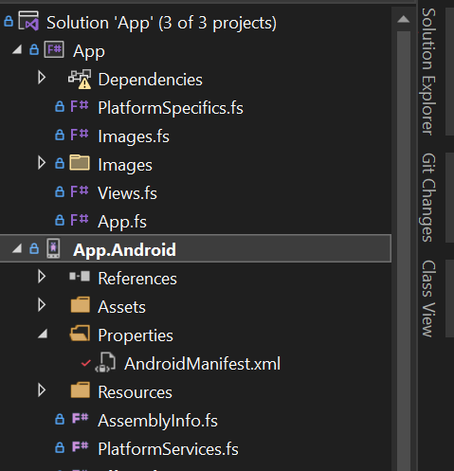

1. Click Properties 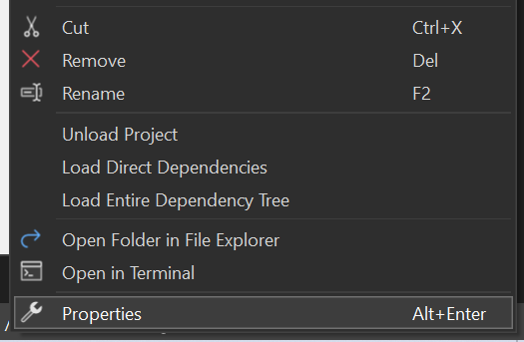
2. Click ”Android Manifest”, and see the “Package name” on the right. This is the app ID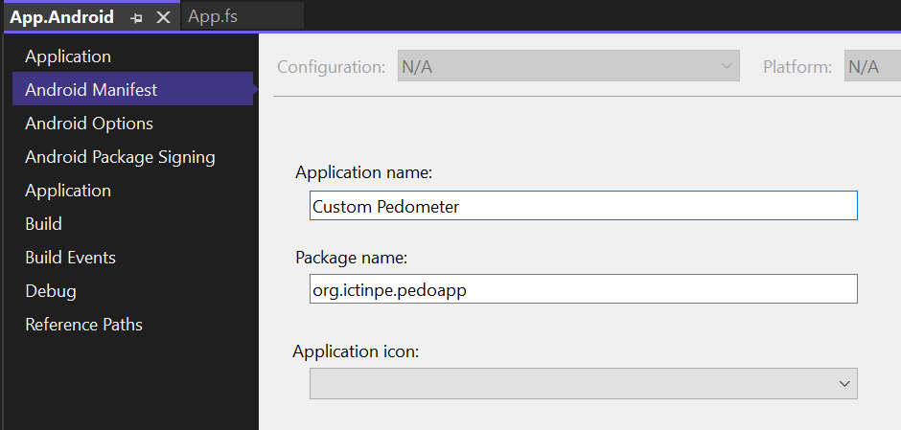
3. We can change the displayed name of the app on our phone screen in “Application name”. Meanwhile, we should also modify “Package name” to something unique, subject to the following restrictions:
   1. It must have at least two segments (i.e. contains one or more dots (.) for separation)
   2. Each segment must start with a letter (i.e. only letters at start or after a dot (.))
   3. All characters must be alphanumeric or an underscore (a-z, A-Z, 0-9, or _)

Typically, these names start with the reversed domain name (ictinpe.org -> org.ictinpe) to avoid collisions, and only then the application identifier (pedoapp, in this case). However, you do not have to follow this convention, just make sure your name is unique enough to not collide with other apps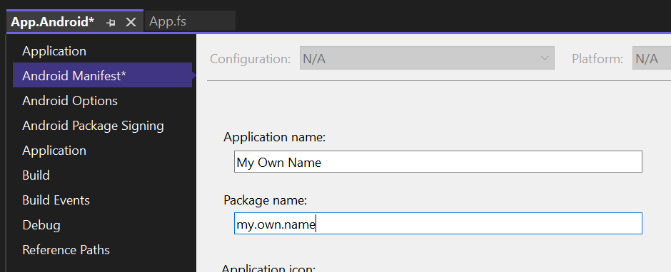

1. Remember to save changes by clicking the icon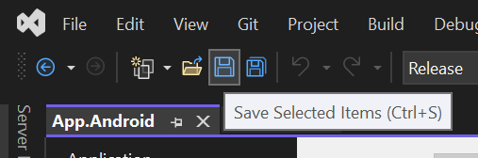
2. Close this tab when done 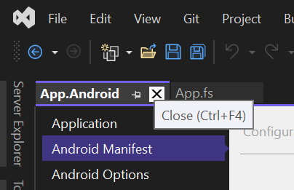

H. APK file generation

1. First we click the Debug on the top bar, then click Release in the dropdown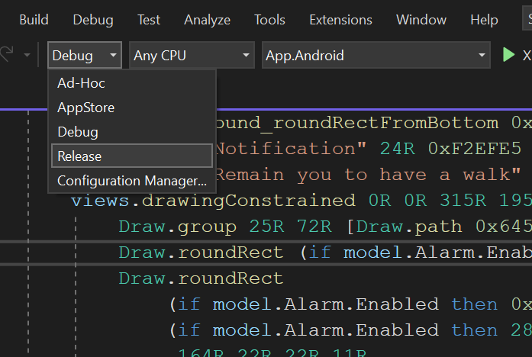
2. In Solution Explorer, right click App.Android 
3. Click “Archive…” 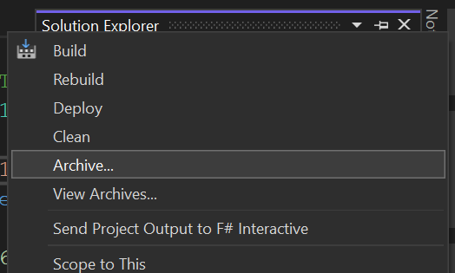
4. Wait for archiving to complete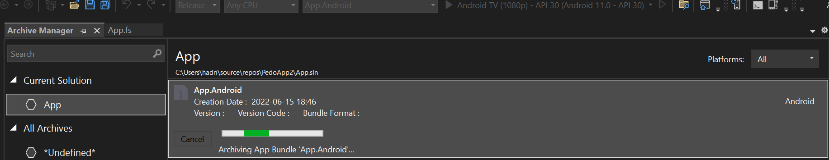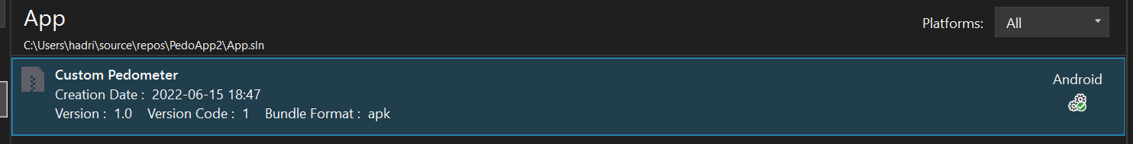
5. Click Distribute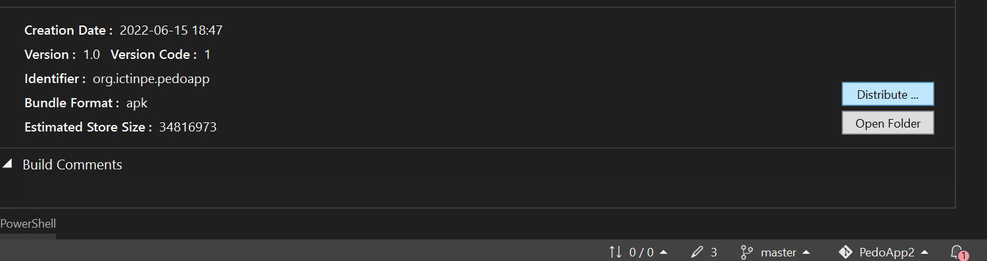
6. Click “Ad-Hoc”. Here, “Google Play” should only be used after we have successfully published our app, which is not applicable here because we haven’t published our app yet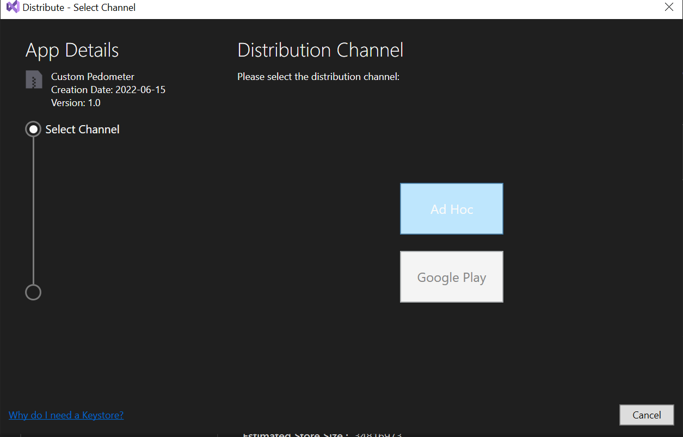
7. Now we are supposed to choose a Signing Identity which we don’t have yet. We can choose to add a new one or import one, here we import a standardized key instead of risking forgetting the password. Meanwhile, for actual apps, we should keep an actual key to prevent impostors from creating apps that impersonate ours. Click “Import…”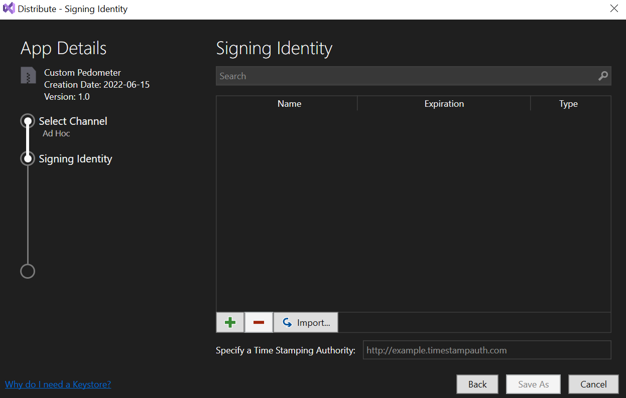
8. Click “…”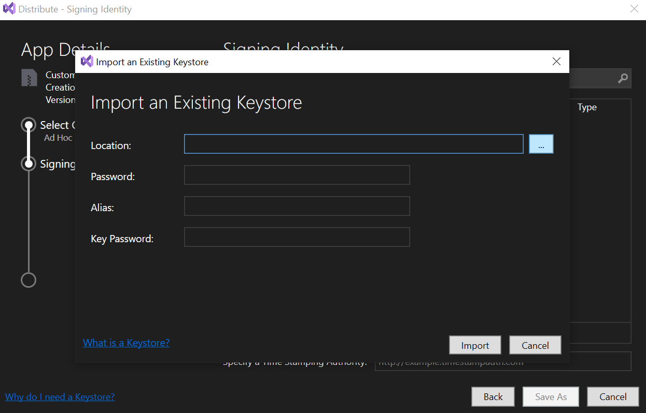
9. Open this URL in a web browser <https://github.com/Happypig375/PedoApp2/raw/master/PedoApp.keystore> 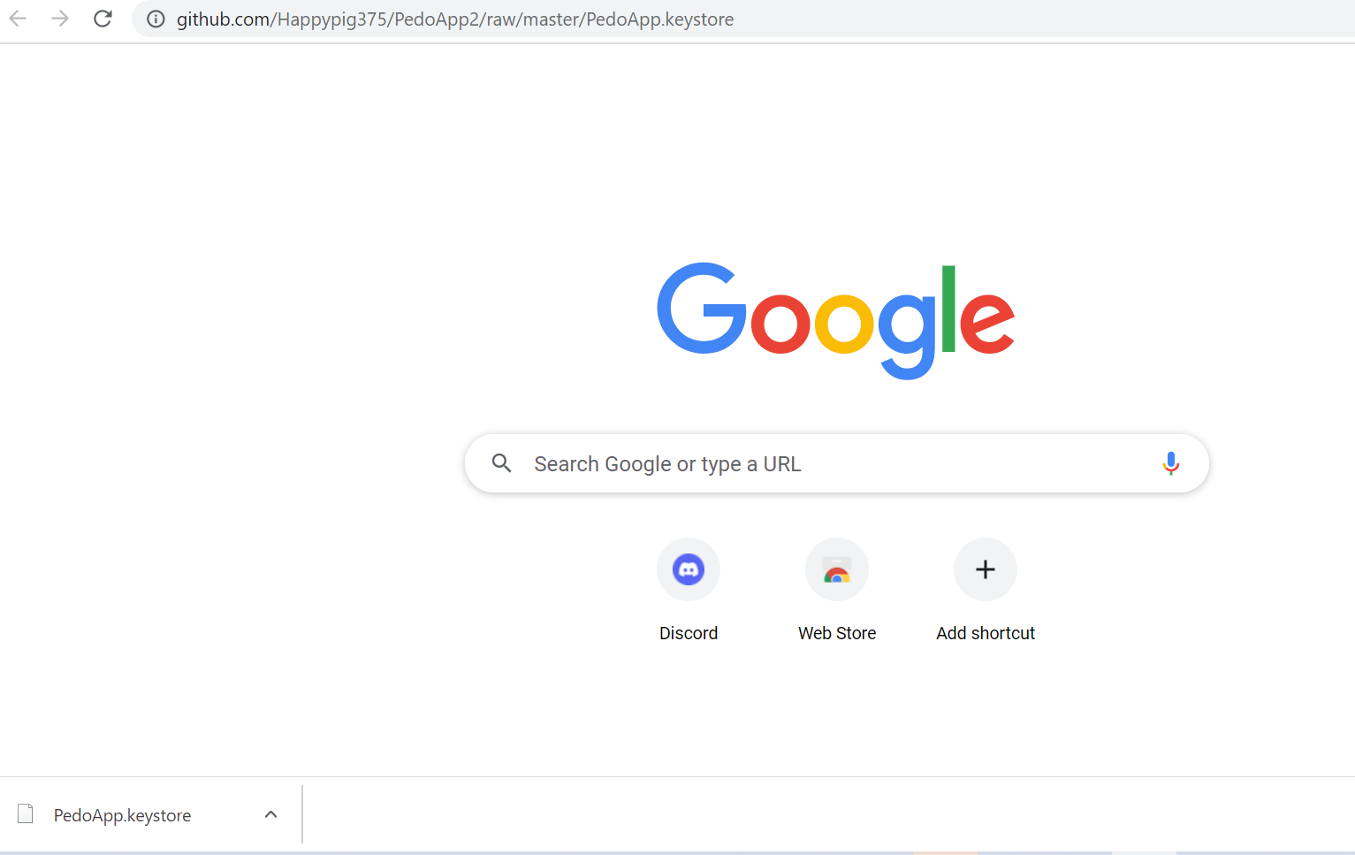
10. Back to Visual Studio, double click the file we just downloaded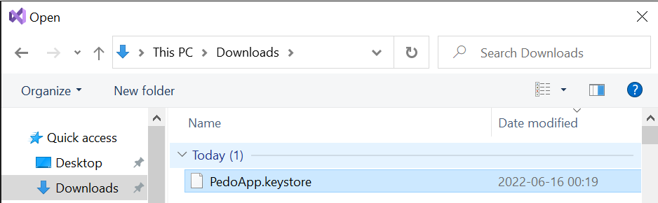
11. Input “PedoApp” (case sensitive) for all three text boxes, then click “Import” 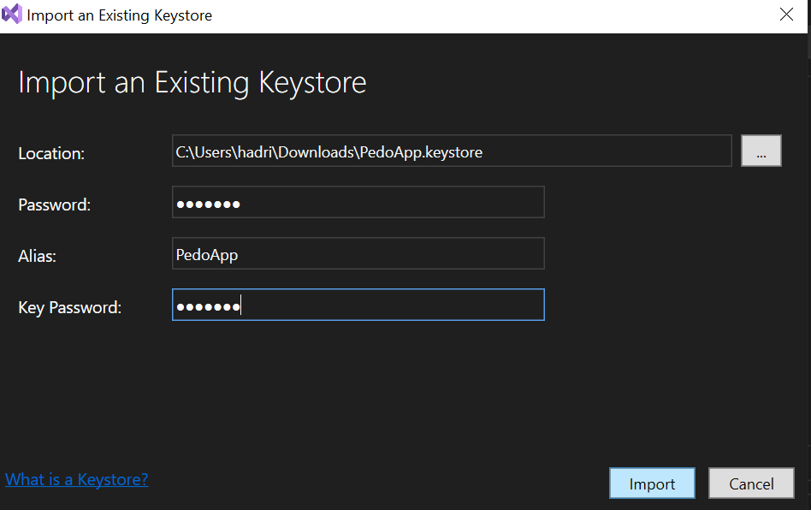
12. Click the “pedoapp” row we just created, then click “Save as” 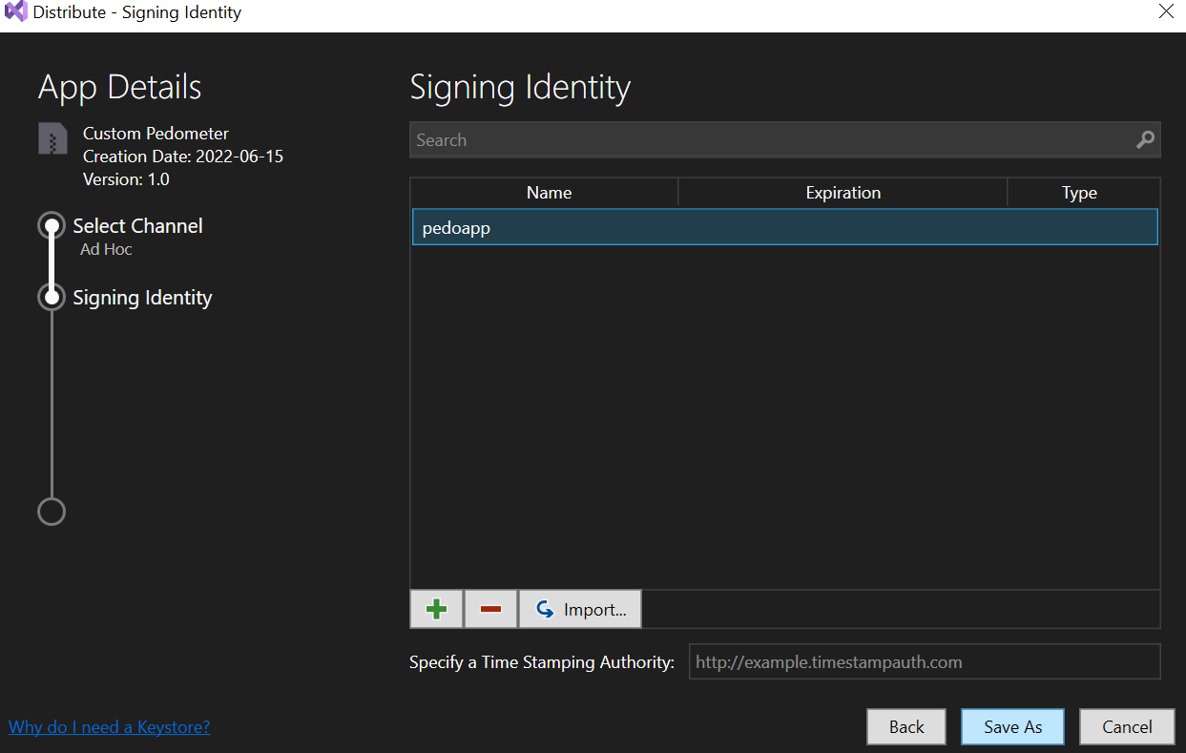
13. Click the Downloads folder, then click Save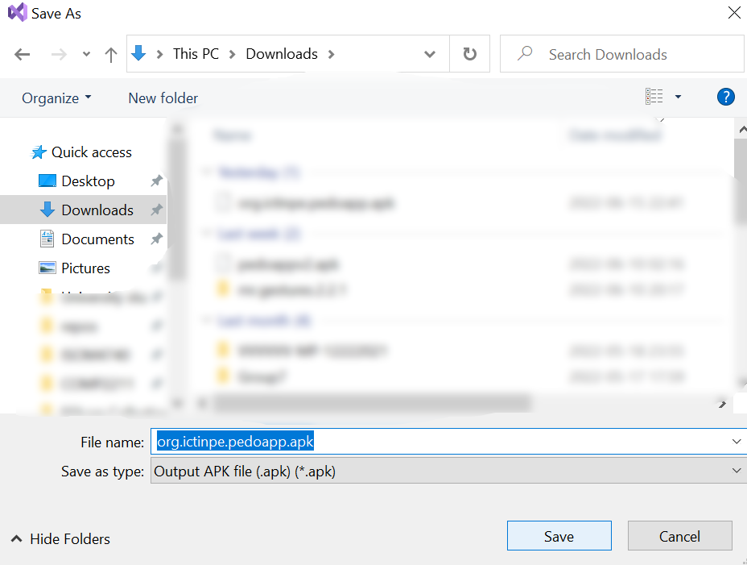
14. Input “PedoApp” (case sensitive) then click OK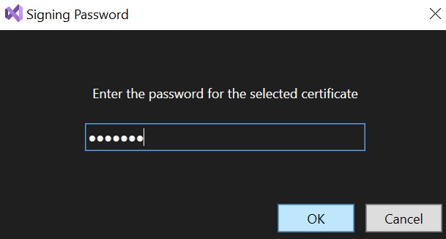
15. Check the Downloads folder, now we have an APK file generated successfully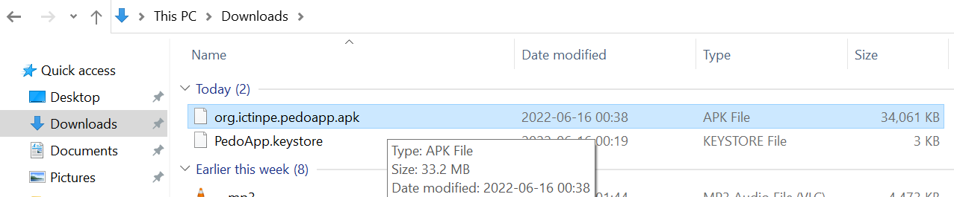

I. Google Play Developer registration

1. In the web browser, open this URL <https://play.google.com/console/about/>, then click “Go to Play Console”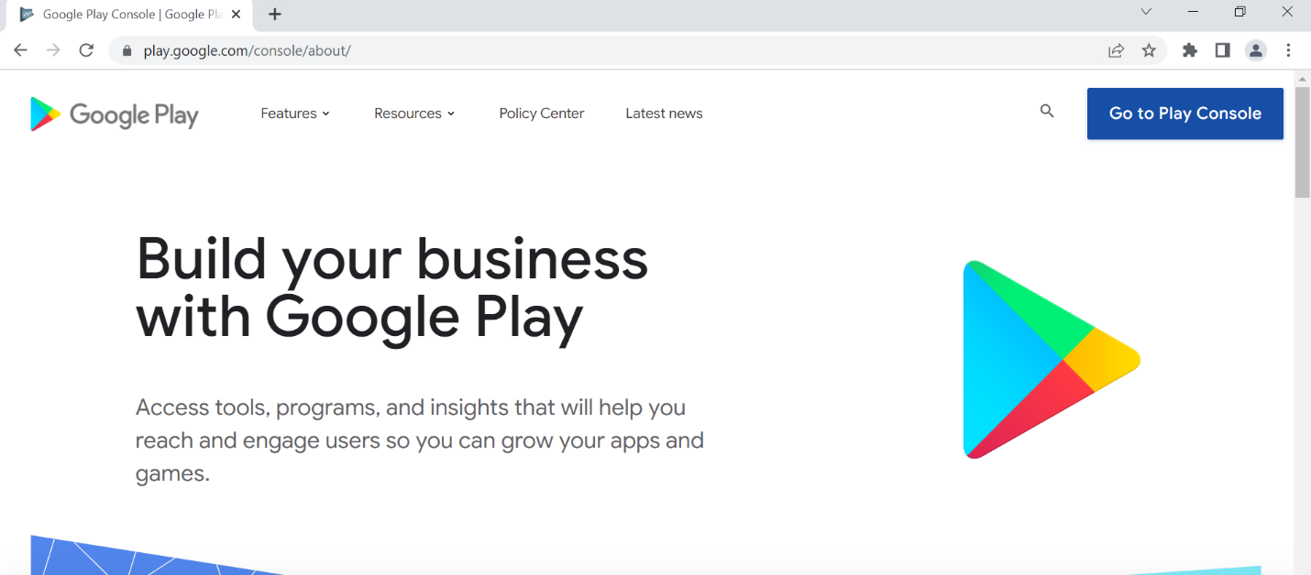
2. Log in with a Google account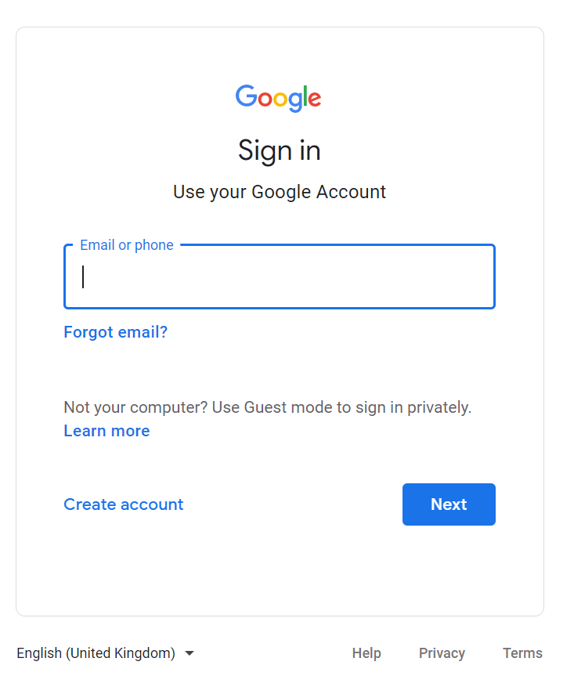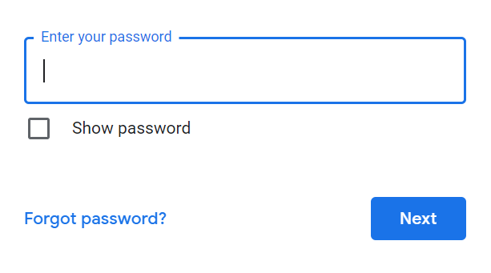
3. Accept new Terms of Service, if requested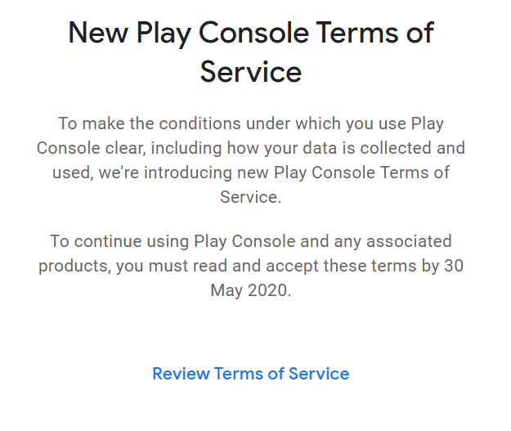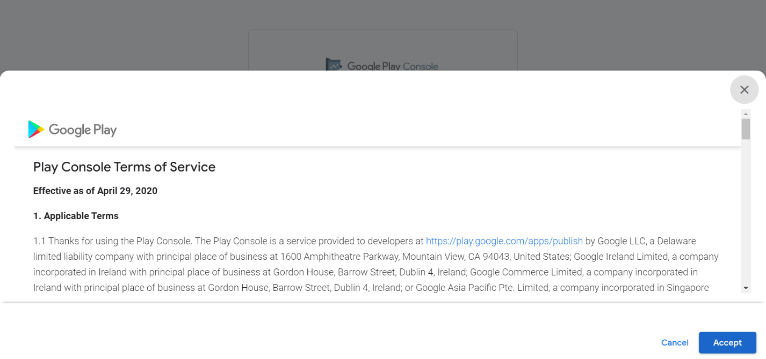
4. Google requires us to turn on 2-step verification before making a developer account so click it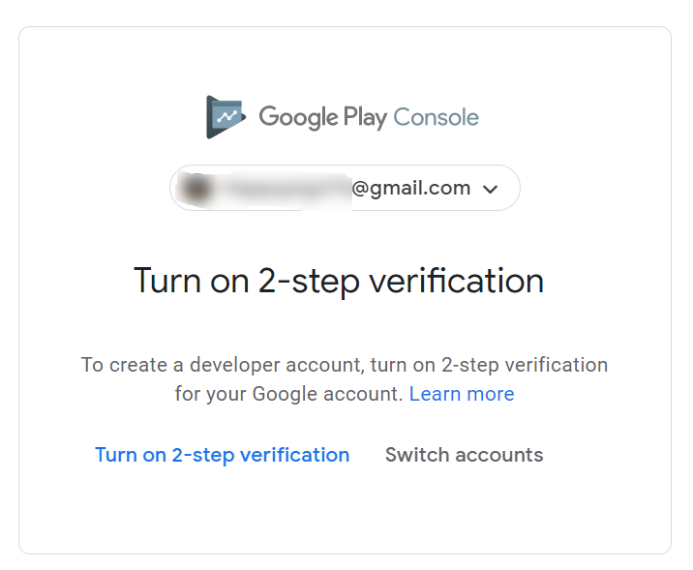
5. Click “Get Started” 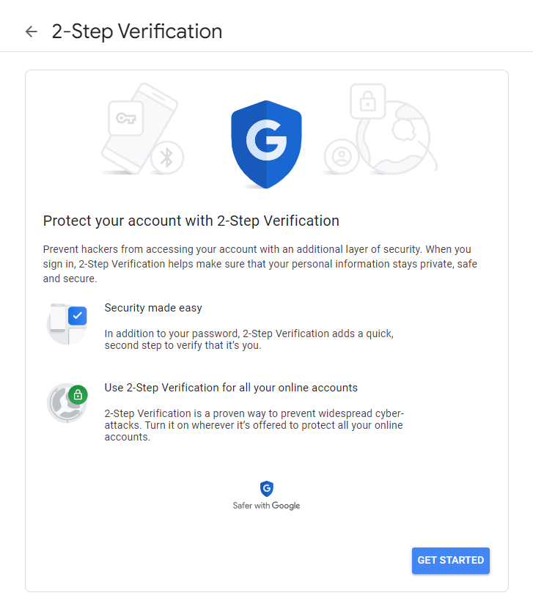
6. Click Next 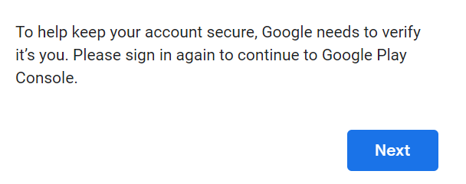
7. Enter password and click Next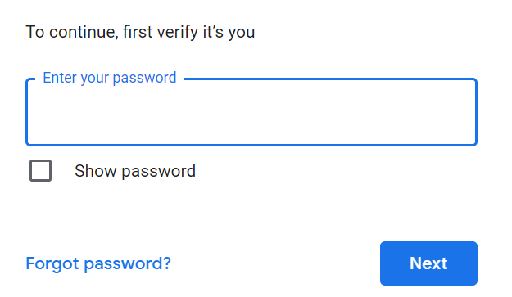
8. Ensure that your phone appears on the prompt, then click Continue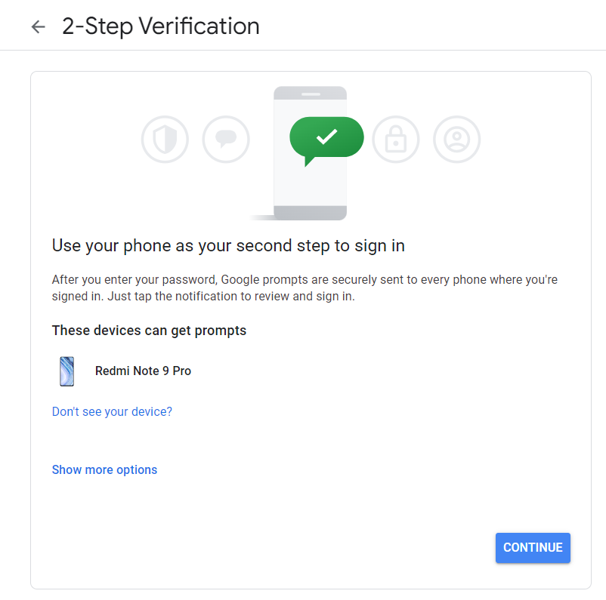
9. Select the correct country from the country box, then enter your phone number in the text box, then click Send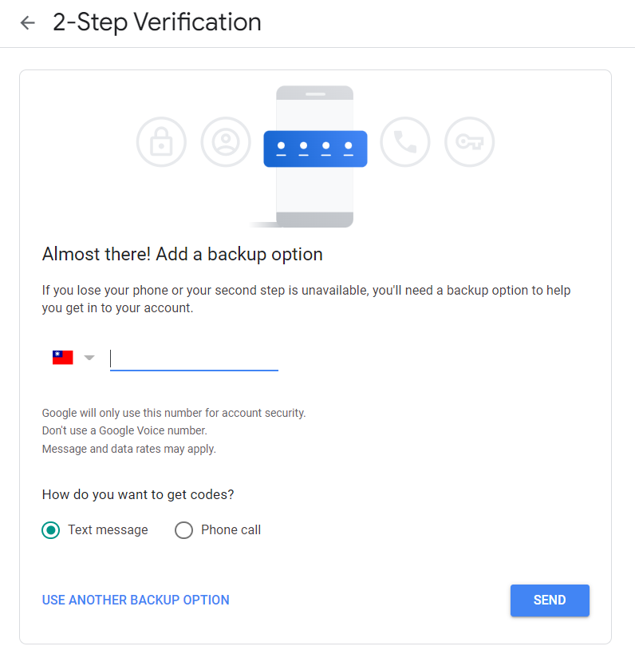
10. Check your phone’s SMS for the verification code
11. 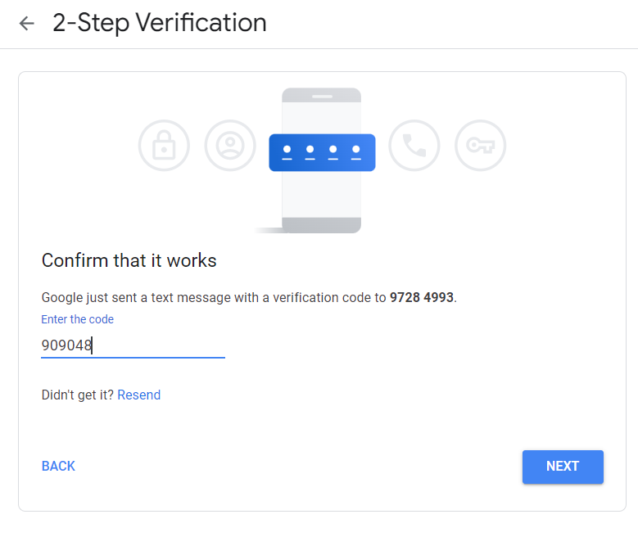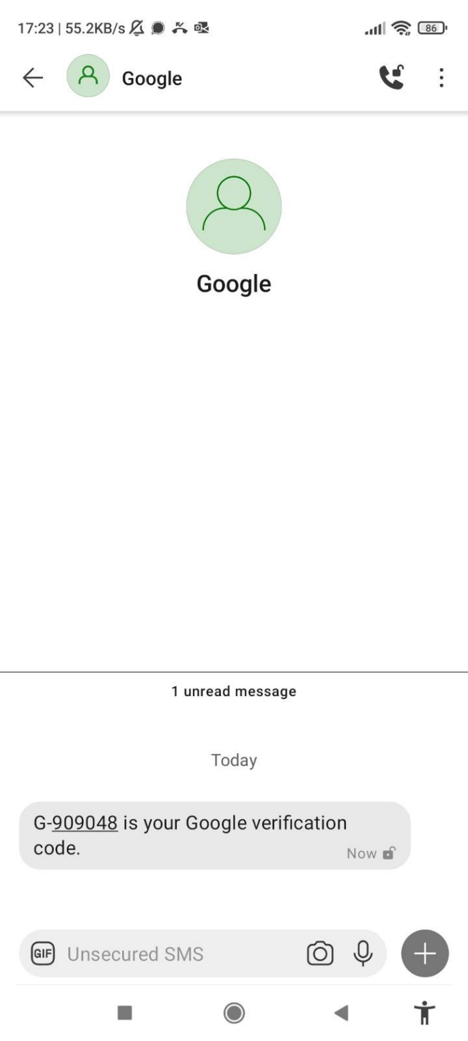Enter the verification code in the browser then click Next
12. Click Turn On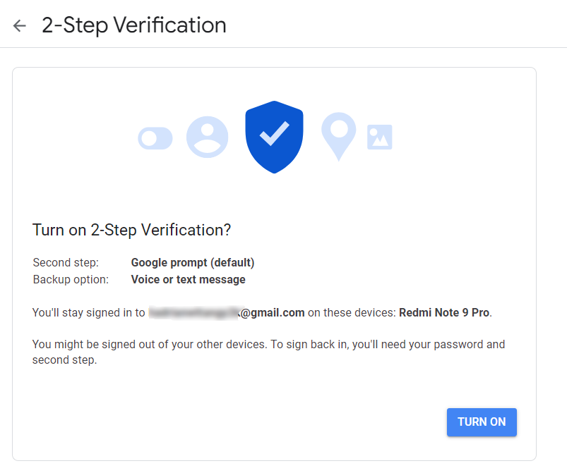
13. Ensure that 2-step verification is turned on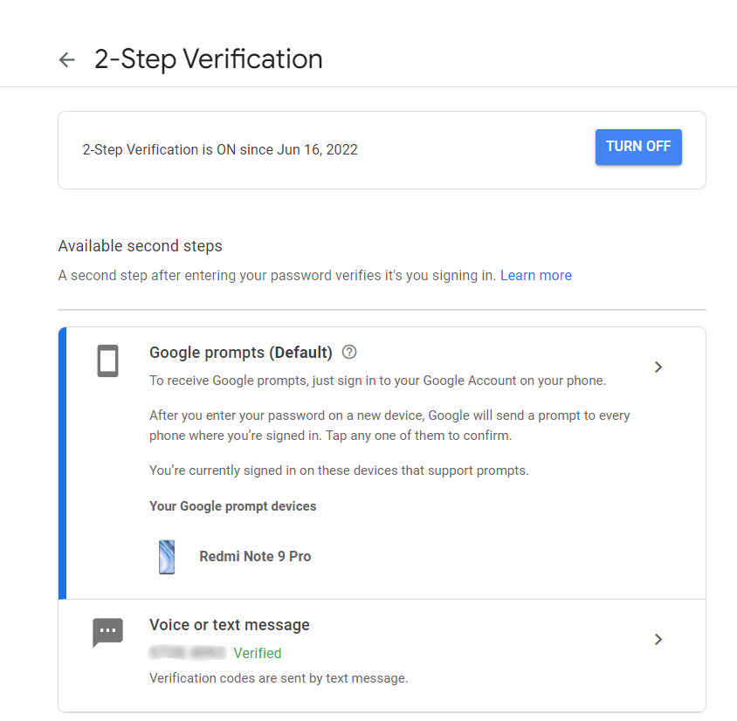
14. Go to this URL again <https://play.google.com/console/about/> and click “Go to Play Console” 
15. Click “Get started” under Yourself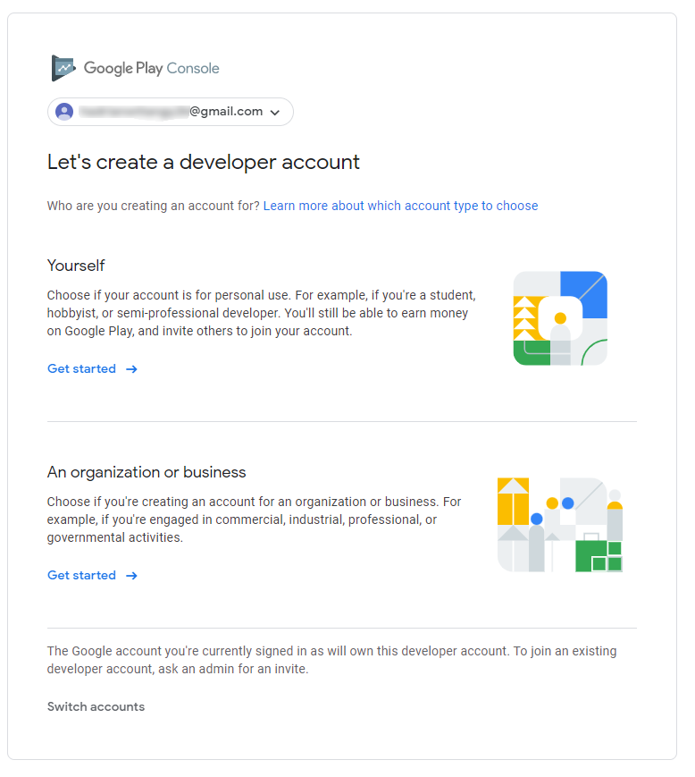
16. Fill information (“Developer name” must be unique, i.e. never used by others)  
     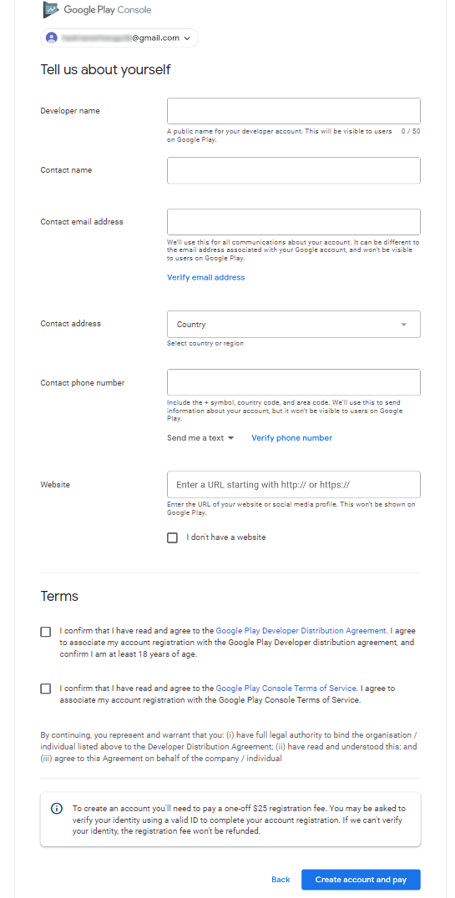
17. Verify email address if requested. You can just write the current gmail address and it will be verified automatically upon clicking “Verify email address” 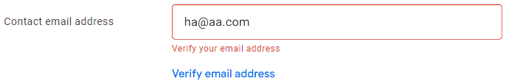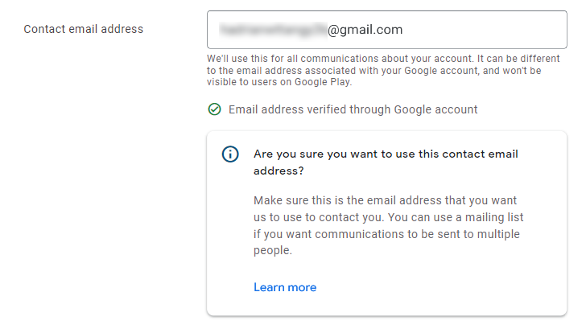
18. 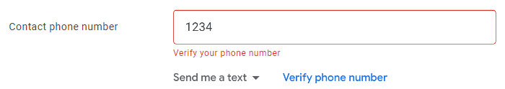Verify phone number if requested. You can just use the phone number you used for two-factor authentication, and check SMS again to fill in the required code

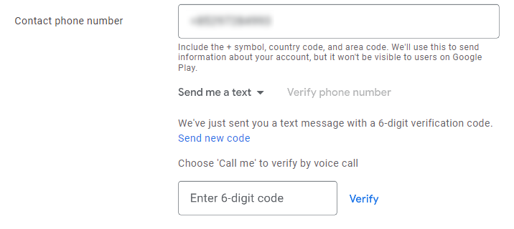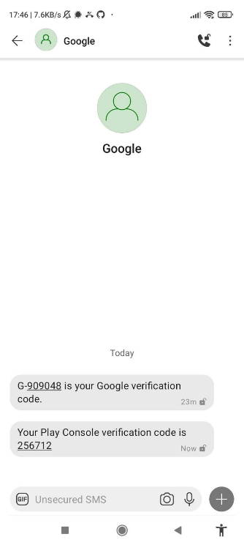

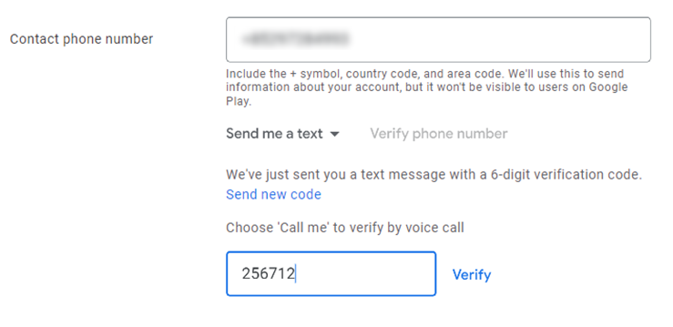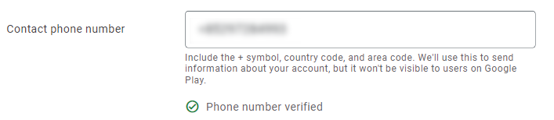

1. Click “Create account and pay” when finished entering information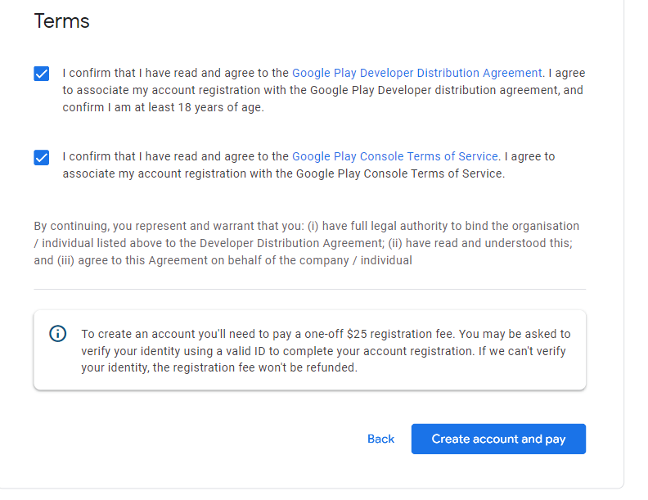
2. Add a credit card or debit card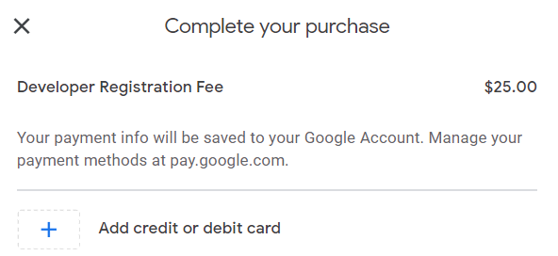
3. Fill in information then click “Save card” 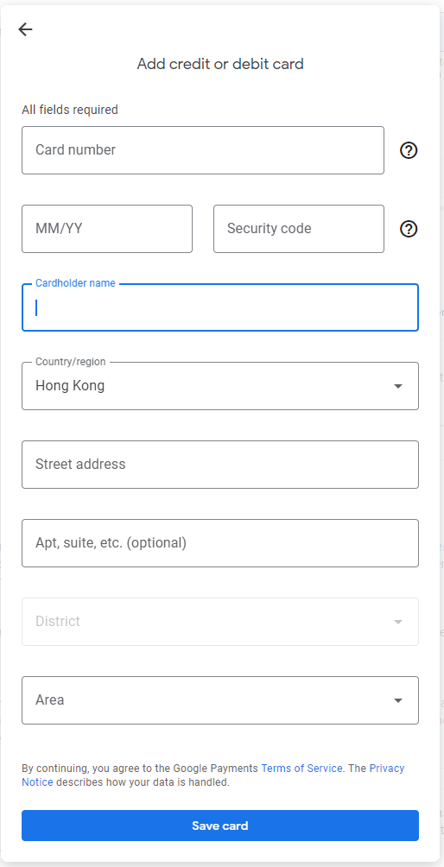
4. Click your card and proceed with the transaction (details omitted)

J. Publishing the app

1. Go to this URL again <https://play.google.com/console/about/>, then click “Go to Play Console”
2. Click the developer account that was just created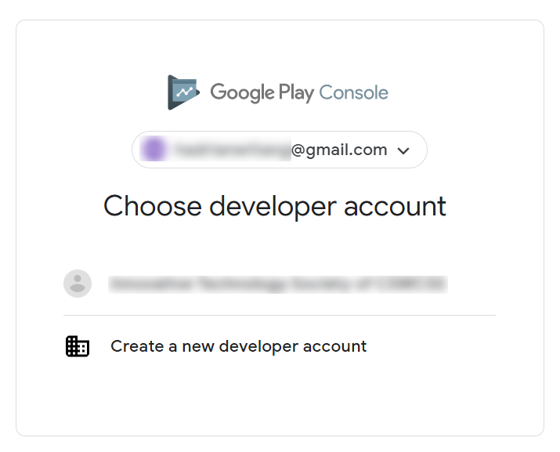
3. Click “Create app” 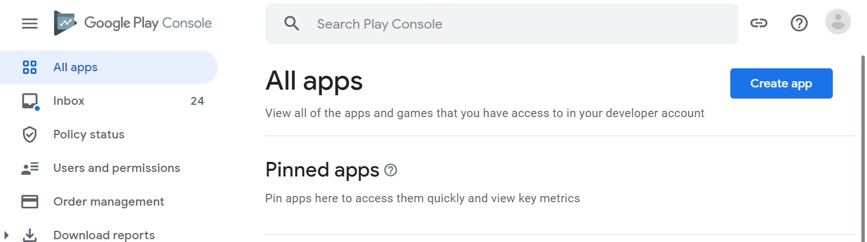
4. Fill in app name, select English as “Default language”, choose “App” and “Free”, and check required check boxes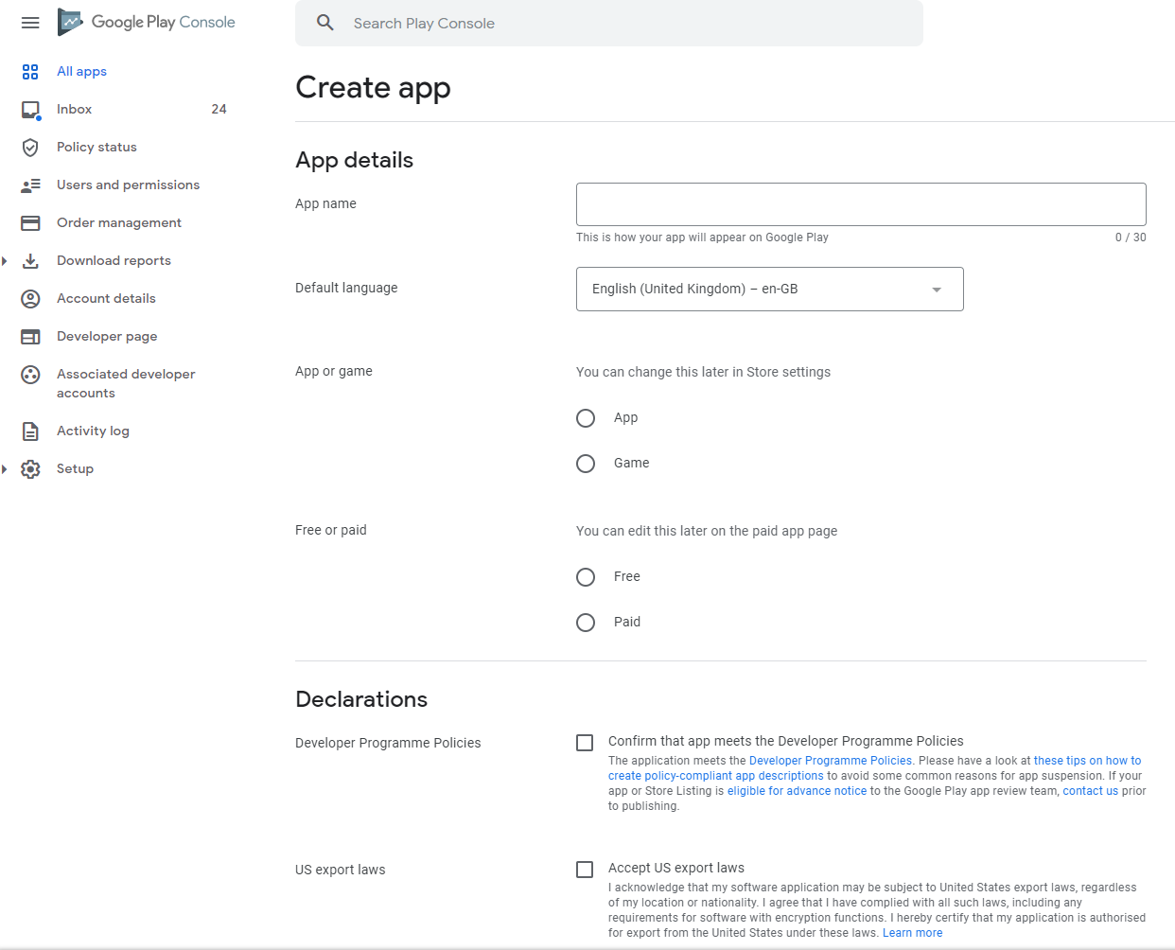
5. Click “Create app” 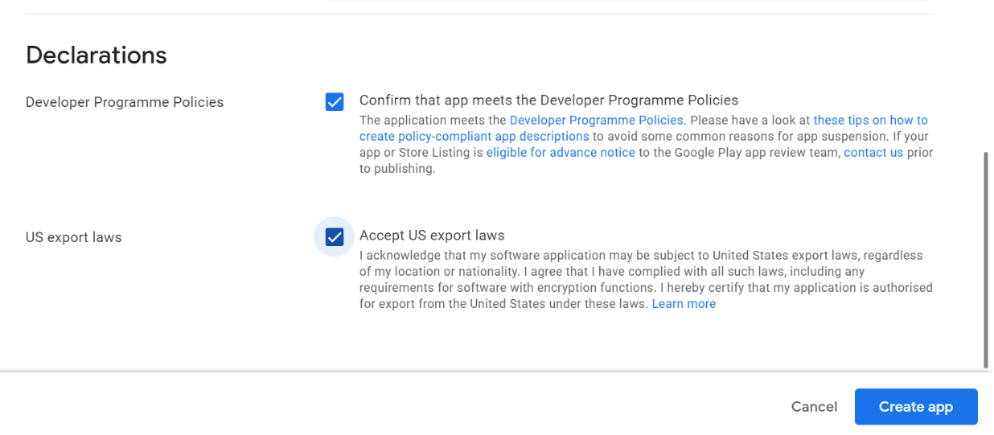
6. 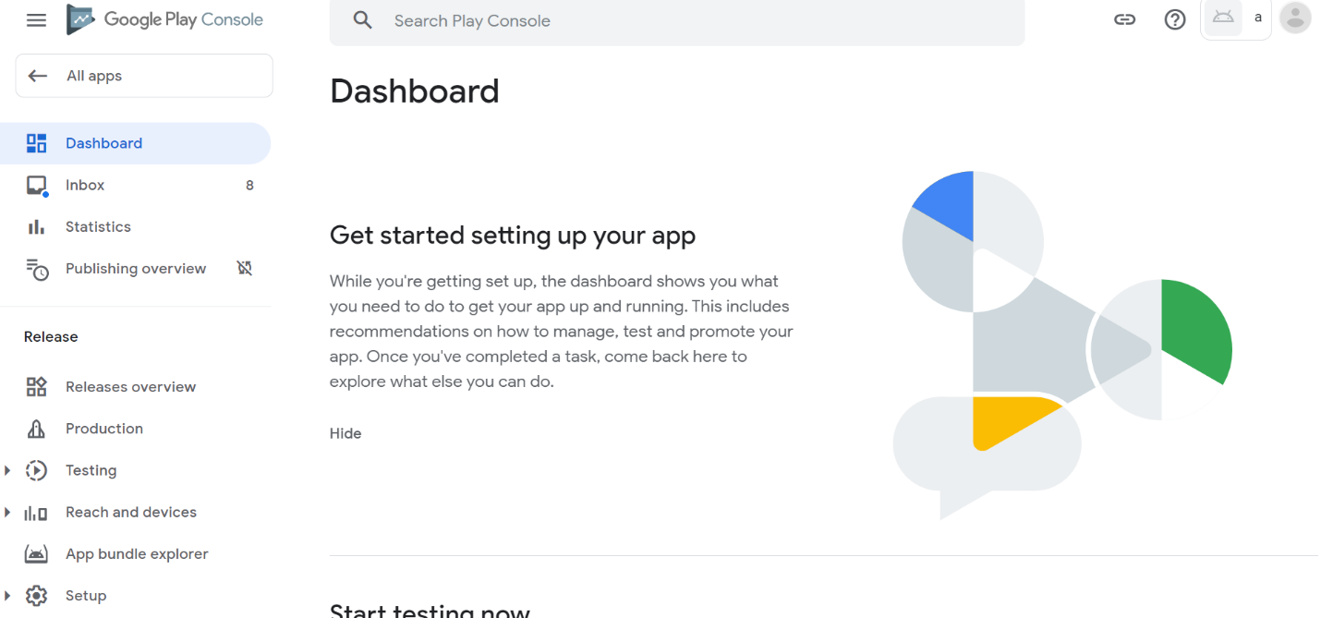Scroll down until “Set up your app” and click “View tasks”